

**PROPOSAL:**

**Curriculum Management System**

**Name 1**

**Submitted by**

Mohi Karim

Verbanet Technologies LLC  
12.03.19

**DIRECTORY.**

1 KEY DETAILS 8

2 STRATERGIC OBJECTIVES 9

3 PROJECT SCOPE 10

3.1 Inventory Management 10

3.1.1 Prototype Screens 11

3.2 Electronic Stock Card 12

3.2.1 Prototype Screens 13

3.3 Stock Movements 16

3.3.1 Prototype Screens 17

3.4 Inventory Management 20

3.4.1 Prototype Screens 20

3.5 Dashboard 23

3.5.1 Prototype Screens 24

3.6 Flexible Location Hierarchy 28

3.6.1 Prototype Screens 28

3.7 Reporting 30

3.7.1 Prototype Screens 30

3.8 Security 34

3.8.1 Prototype Screens 35

4 DEFENITION of TERMS 39

4.1 USER CHARACTERISTICS 41

4.1.1 Generic user 41

4.1.2 Faculty/staff user 41

4.1.3 Admin user 41

4.1.4 Workflow User: Can also be in one of the three previous categories 41

4.1.5 Sample Create Course Workflow, Roles, Permissions 41

4.2 PROPOSED SOLUTION MODEL 44

4.3 FUNCTIONAL REQUIREMENTS 45

4.4 COURSE MANAGEMENT 46

4.4.1 Course Information 46

4.4.2 Course Processes 48

4.5 PROGRAM MANAGEMENT 49

4.5.1 Program Information 49

4.5.2 Program Processes 50

4.6 COURSE SET MANAGEMENT 51

4.7 LEARNING OBJECTIVES MANAGEMENT 51

4.8 ORAGANIZATION, PEOPLE and ROLES MANANAGEMENT 52

4.9 WORKFLOW STATES 54

4.10 PROPOSAL STATES 54

4.11 COURSE STATES 55

4.12 COURSES and PROPOSAL WORKFLOW with STATES 57

5 APPLICATION SERVICES 58

5.1 Academic Time Period Service 58

5.1.1 Description 58

5.1.2 Key Concepts 58

5.2 Canonical Learning Unit (CLU) Service 59

5.2.1 Description 59

5.2.2 Key Concepts 59

5.3 Comment Service 62

5.3.1 Description 62

5.3.2 Key Concepts 62

5.4 Course Service 63

5.4.1 Description 63

5.4.2 Key Concepts 63

5.5 Document Service 64

5.5.1 Description 64

5.5.2 Key Concepts 64

5.6 Enumeration Management Service 65

5.6.1 Description 65

5.6.2 Key Concepts 65

5.7 Learning Objective Service 65

5.7.1 Description 65

5.7.2 Key Concepts 65

5.8 Learning Result Catalog Service 66

5.8.1 Description 66

5.8.2 Key Concepts 67

5.9 Message Service 68

5.9.1 Description 68

5.9.2 Key Concepts 68

5.10 Organization Service 68

5.10.1 Description 68

5.10.2 Key Concepts 68

5.11 Program Service 69

5.11.1 Description 69

5.11.2 Key Concepts 69

5.12 Proposal Service 70

5.12.1 Description 70

5.12.2 Key Concepts 71

5.13 Search Service 72

5.13.1 Description 72

5.13.2 Key Concepts 72

5.14 State Service 72

5.14.1 Description 72

5.14.2 Key Concepts 73

5.15 Version Management Service 73

5.15.1 Description 73

5.15.2 Key Concepts 74

6 DETAILED REQUIRMENT SPECIFICATIONS 75

7 APPLICATION ARCHITECHURE 82

7.1 COURSE CREATION WORKFLOW 82

7.2 ENTITY RELATIONSHIP DIAGRAMS 83

7.2.1 ATP Service 83

7.2.2 Canonical Learning Unit 84

7.2.3 Comment Service 85

7.2.4 Course Service 86

7.2.5 Document Service 87

7.2.6 Enumeration Management Service 88

7.2.7 Learning Objective Service 89

7.2.8 Learning Result Catalog Service 90

7.2.9 Message Service 91

7.2.10 Organization Service 92

7.2.11 Program Service 93

7.2.12 Proposal Service 94

7.2.13 State Service 95

7.2.14 Version Management Service 95

7.3 LOCAL SERVER INSTANCE (On Premise) 96

7.4 Sample Screens 97

7.4.1 Course List 97

7.4.2 Course View 98

7.4.3 Form Changes (Tracking) 99

7.4.4 Rich Text Content 100

7.4.5 Tagging Courses 101

7.5 NON-FUNCTIONAL REQUIREMENTS (OTHERS) 102

7.6 TECHNICAL CONFIGURATIONS 102

7.6.1 DEVELOPMENT ENVIRONMENT 102

7.6.2 RECOMMENDED WED HOSTING PACKAGE - DEDICATED 103

7.6.3 BROWSER 103

7.6.4 HARDWARE DEVICES 103

7.6.5 TECHNICAL STANDARDS 104

7.6.6 TECHNICAL GUIDELINES 104

7.7 PROJECT DELIVERY 106

7.7.1 Agile Methodology 106

7.7.2 PROJECT MANAGEMENT 108

7.7.3 ROLES & RESPONSIBILITIES 109

7.7.4 DELIVERY ACTIVITY SUMMARY 110

7.7.5 PROJECT IMPLEMENTATION PLAN 111

7.7.6 DELIVERABLES 111

7.7.7 ESTIMATED DELIVERY TIME 112

7.7.8 DEPLOYMENT DETAILS 114

7.7.9 RELEASE PLANNING 114

7.7.10 RISK CONTINGENCY PLANNING 114

7.8 PROJECT ASSUMPTIONS 116

7.8.1 OBJECTIVES 116

7.8.2 DESIGN 116

7.8.3 DEVELOPMENT 116

8 OUT OF SCOPE 117

9 CHANGE MANAGEMENT 119

9.1 MAINTENANCE & SUPPORT 120

10 TERMS AND CONDITIONS 121

10.1 ACCEPTANCE CRITERIA 121

10.2 WARRANTY 121

10.3 SOURCE CODE & INTELLECTUAL PROPERTY RIGHTS 122

10.4 GENERAL TERMS AND CONDITIONS 122

10.5 GENERAL ADMINISTRATIVE, TECHNICAL & FUNCTIONAL ASSUMPTIONS 124

11 FINANCIALS 125

11.1 Curriculum Management Application 125

11.2 PAYMENT TERMS 125

11.2.1 MODE OF PAYMENT 126

# KEY DETAILS

**PROJECT NAME CLIENT**

Curriculum Management System Client 1

**CLIENT CONTACT PROPOSAL ID NO.**

Name 1 AD/BP/12032019/2609/1

m.aldarabee@gmail.com

+966 59 011 1298

**PROPOSAL SUBMISSION ANTICIPATED START DATE**

12.03.19  TBD

**PROPOSAL VALID UNTIL PROPOSED TECHNOLOGY**

11.04.19 JAVA, SPRING

CSS3, HTML5

Responsive Web Application

**PROPOSAL SUBMITTED BY APPLICATION TYPE**

Mohi Karim Web & Mobile Application

Verbanet Technologies L.L.C

Dubai, U.A.E

+971 4 297 3236

Mohi.karim@verbat.com

# STRATERGIC OBJECTIVES

The Ministry of Foreign Affairs (MOFA) has floated an RFP towards the development of an Inventory Management System (IMS).

The current process used by MOFA is a manual process where “material Request” is made via an existing internal portal (email application form). This information is relayed to the warehouse and the order is processed. The functional requirements section of this document shall cover the detailed requirements expressed in the RFP

Verbat is proposing the development of an IMS with the following features

* Inventory Management
* Electronic Stock card
* Stock Movements
* Inventory Tracking
* Dashboard
* Flexible Location Hierarchy
* Reporting
* Security
* Email Notifications
* Stock List Movements

# PROJECT SCOPE

Verbanet Technologies L.L.C., (hereafter referred under its trade / brand name as” Verbat”) in partnership with the Ministry of Foreign Affairs (MOFA) shall develop a Consumables Management System (CMS) aka Inventory Management System (IMS). The system shall be a Responsive Web Application. Verbat had developed an IMS solution for one of its clients who were in the health care domain. The application that was developed had many lock, stock and barrel features of a traditional IMS. Verbat acknowledges, each client has requirements specific to their business; hence the features unique to the business shall be called out separately in further sections of this document. This proposal shall cover the features that are standard for an Inventory Management System as well as the customization required by the client

The features listed below details the basic functionality of the application.

## Inventory Management

The system shall manage inventory at multiple levels: bin location, product, lot/serial number, and expiration date. It shall have the following features

* Manage multiple facilities across multiple regions
* Manage bin locations and bulk storage areas within each storage facility
* Make adjustments to quantity and bin location during inventory activities
* Track reasons for adjustment (i.e. expiry, damage, loss)
* Export suggested cycle count for each location based on last inventory date
* Remove quantity from inventory due to expiry, damage, or recall

### Prototype Screens

#### Browse Inventory

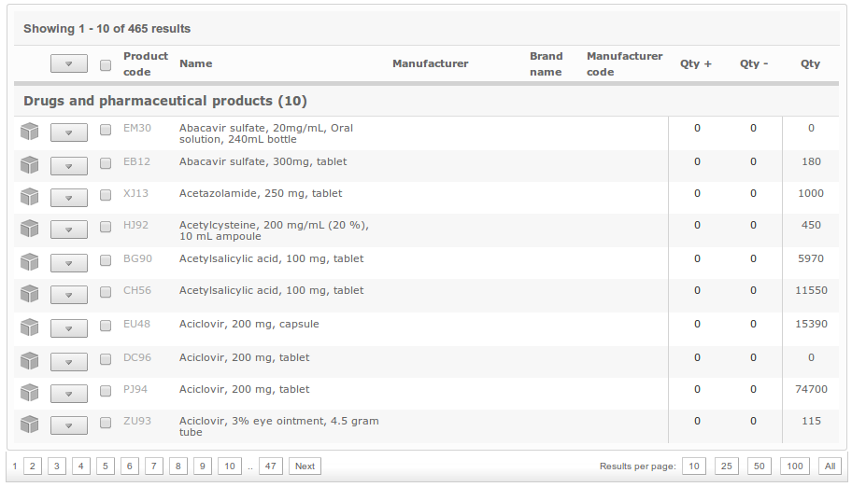

#### Manage Inventory

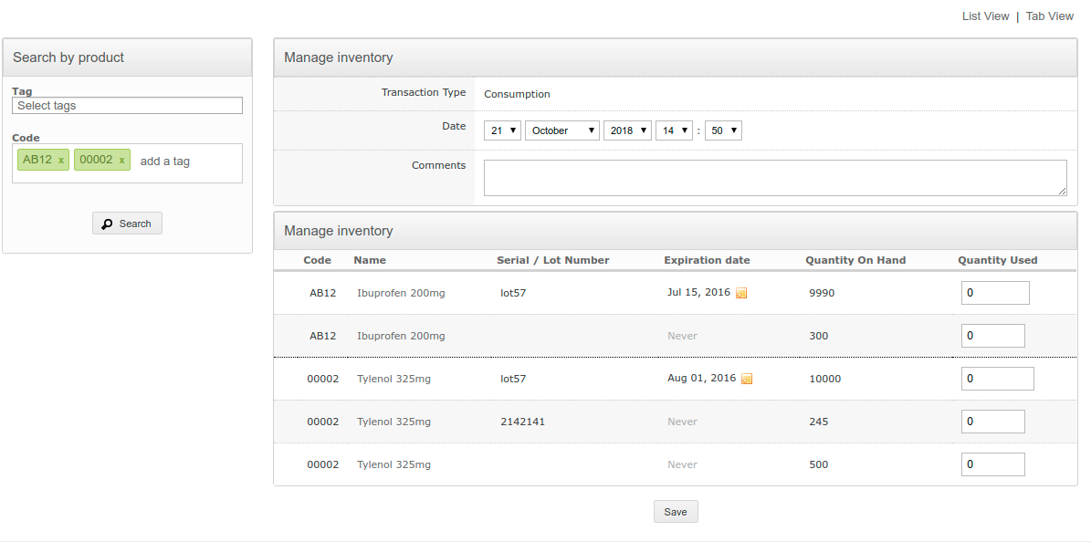

#### Inventory Dashboard

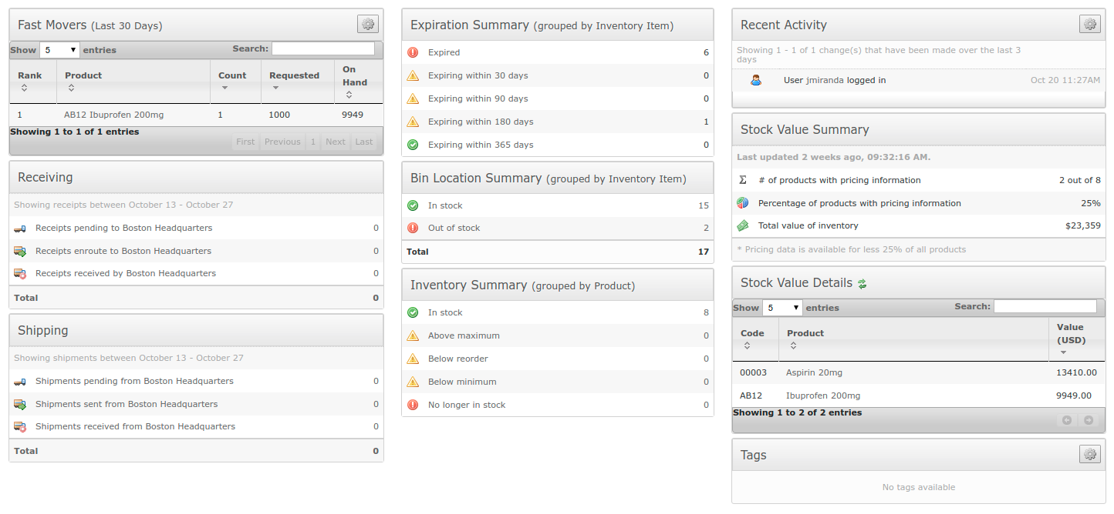

## Electronic Stock Card

The application shall support any type of item including, but not limited to, medications, medical supplies and devices, office supplies, and building materials. In addition, the software shall be used to track the location of fixed assets like automobiles, IT equipment, and hospital furniture.

* Store metadata about each item, including cost, suppliers and manufacturers, category/classification, and substitutions.
* Create custom attributes for temperature requirements, hazardous material class, and import/export requirements (e.g. for controlled substances).
* View quantity on hand within each inventory location by bin location, lot/serial number, and expiration date
* View stock history including debits, credits, and inventory adjustments

### Prototype Screens

#### Current Inventory

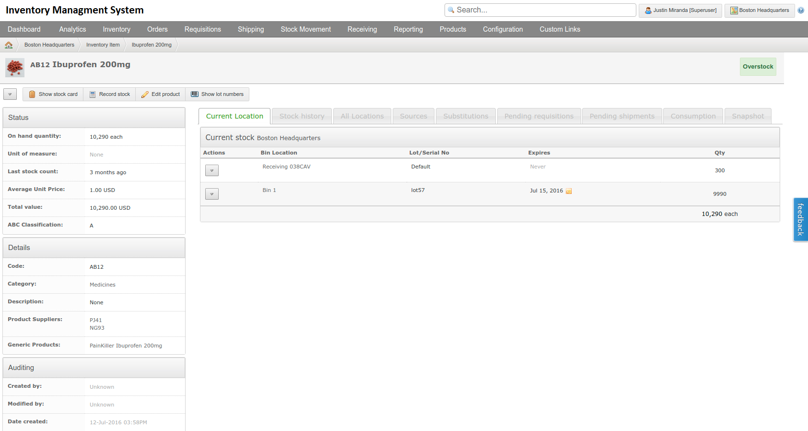

#### Stock History

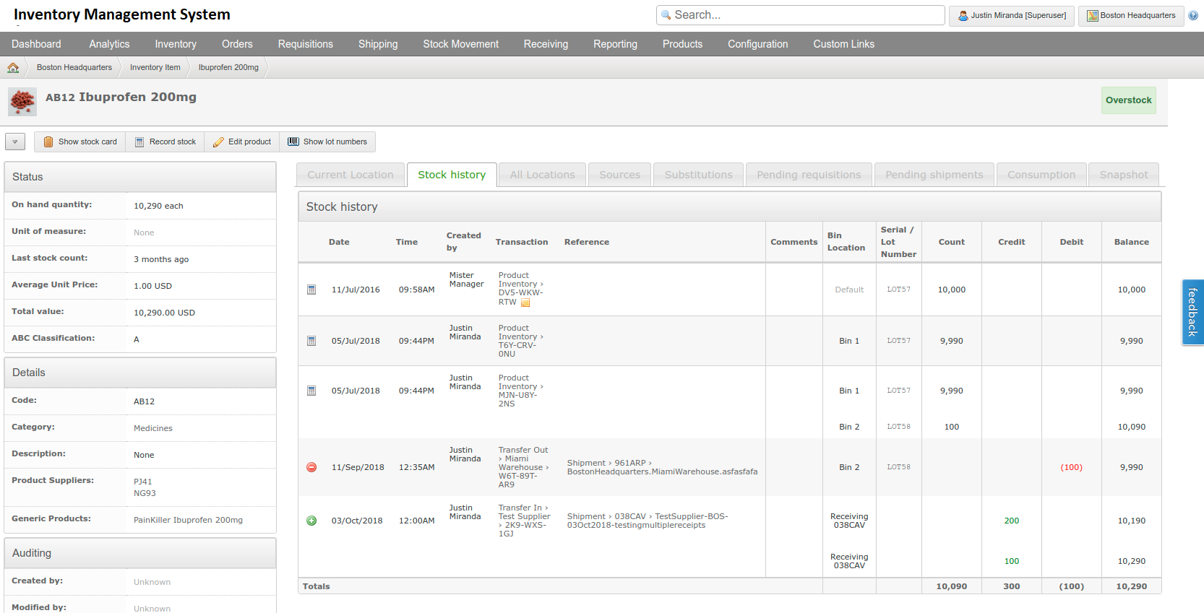

#### Stock Consumption

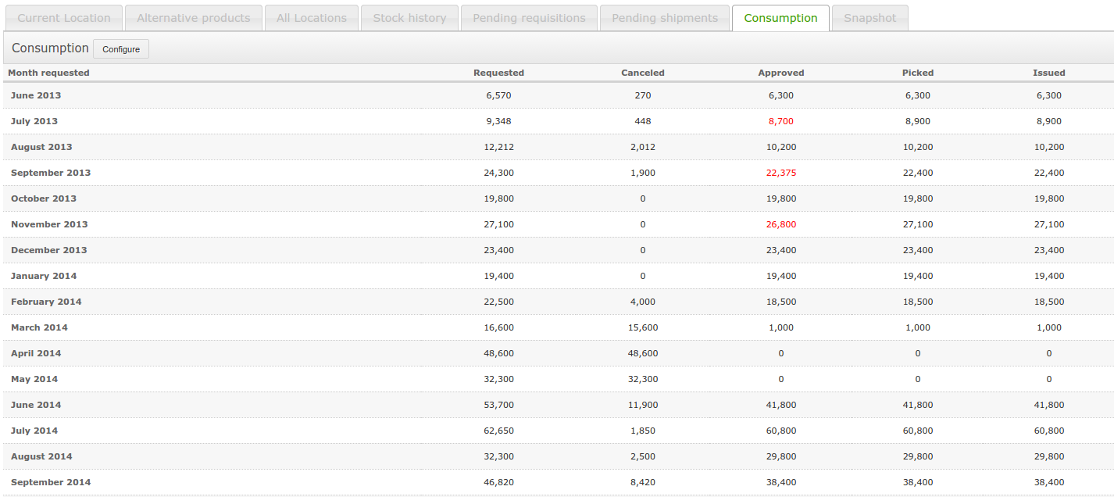

#### Edit Master Product

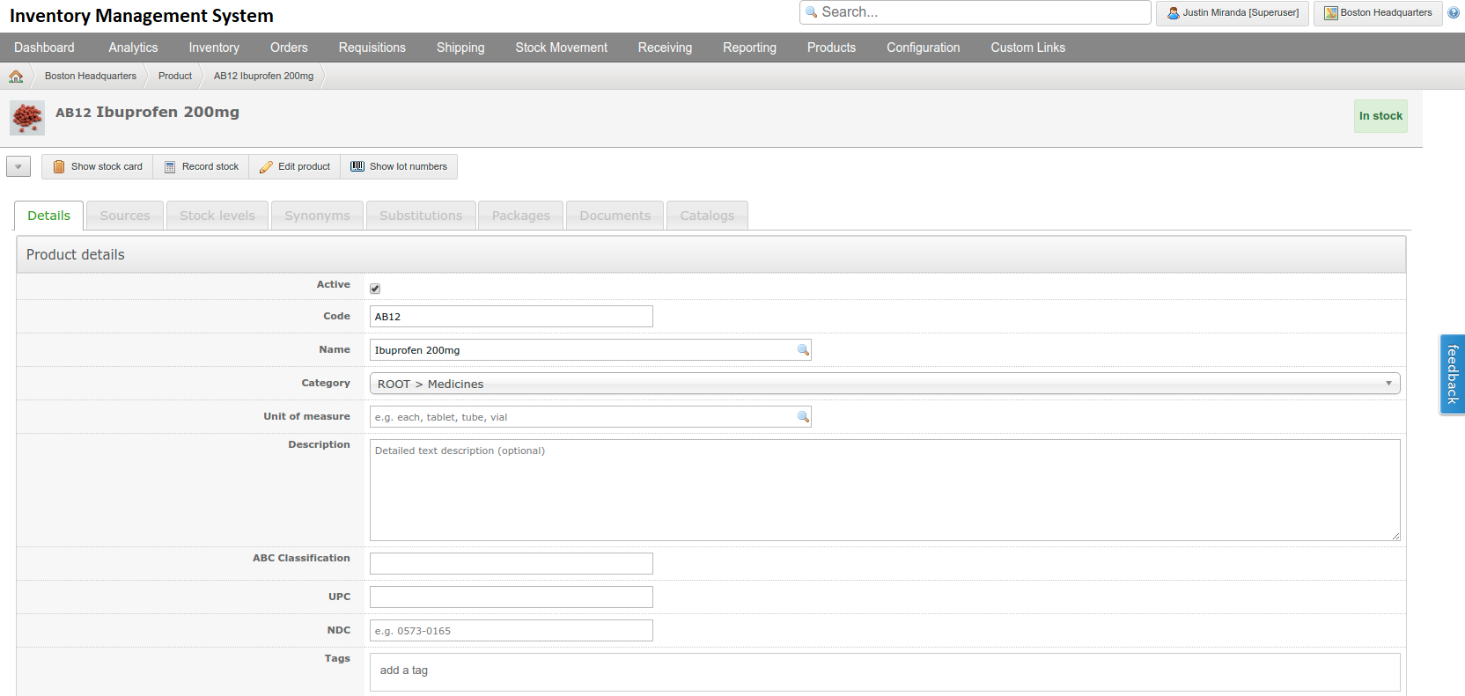

#### Stock Substitutions

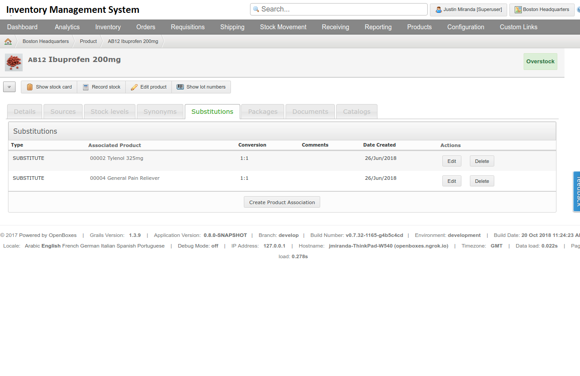

#### Image upload

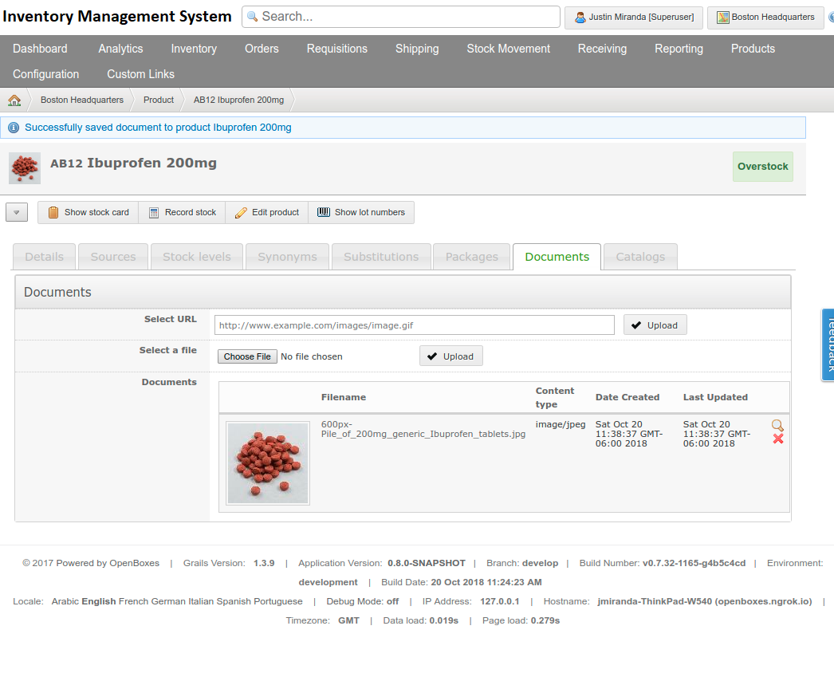

## Stock Movements

The Inventory Management System shall have Intuitive workflows to manage movement of stock from a supplier to depot, from depot to depot, and from depot to consumption location.

It shall have the following features

* Based on the origin and destination entered, the IMS selects the appropriate workflow for moving stock (i.e. incoming from a supplier, depot to depot, depot to consumption location)
* Ability to base a stock movement on a stock list
* Ability to edit quantity in stock movement based on availability of stock while capturing original request to inform forecasting
* Ability to act on suggested substitutions during stock movement workflow
* Automated suggested pick based on FEFO
* Ability to export and print pick list
* Ability to pack items by pallet and box
* Ability to add stock movement metadata including date, tracking number, comments
* Ability to export packing lists and other customized customs clearance documentation
* Ability to upload and store other documentation

### Prototype Screens

#### Create Instance

#### Add Item

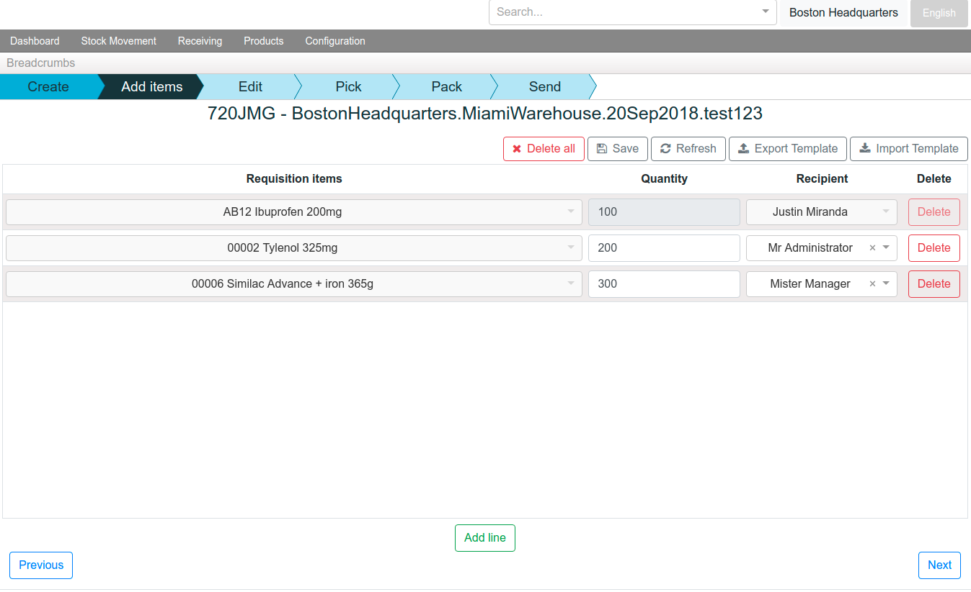

#### Edit Item

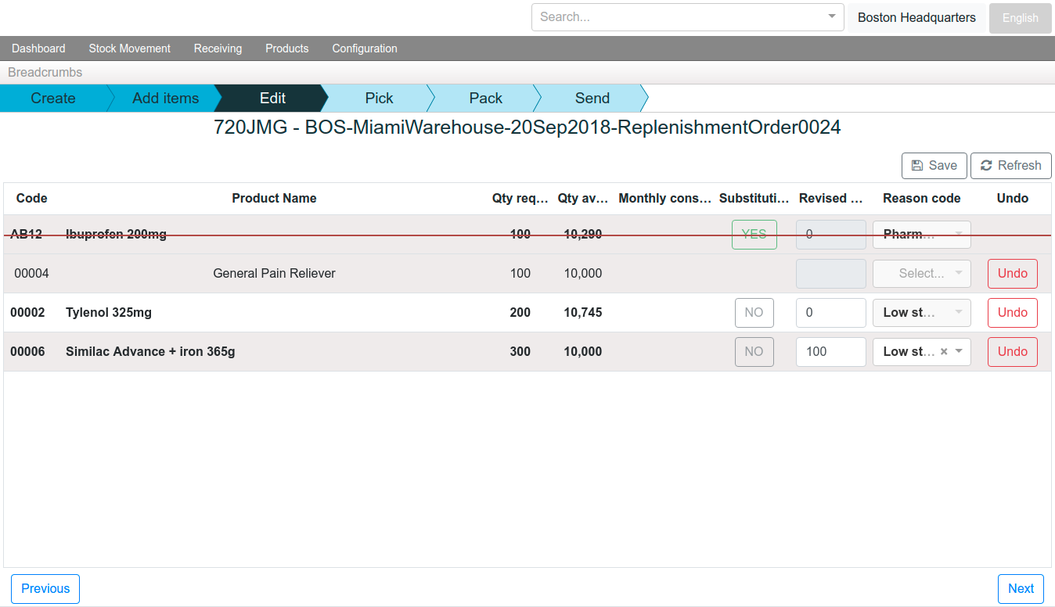

#### Pick Item

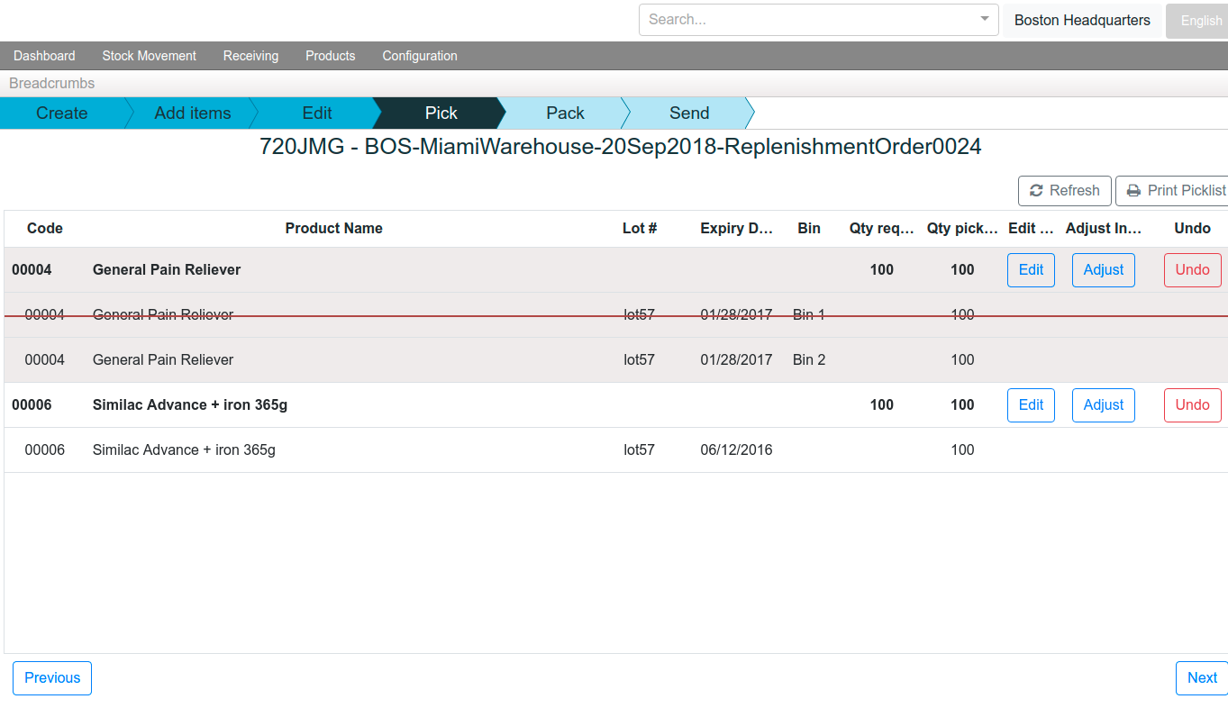

#### Pack Item

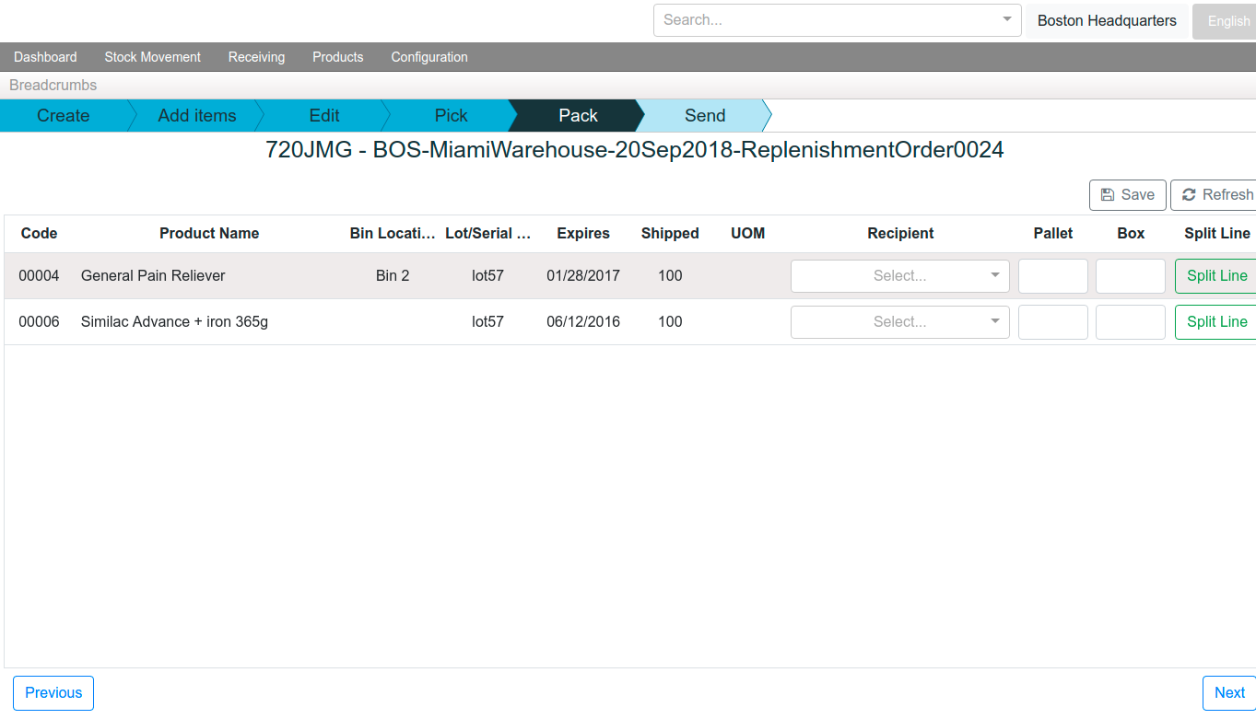

#### Send Item

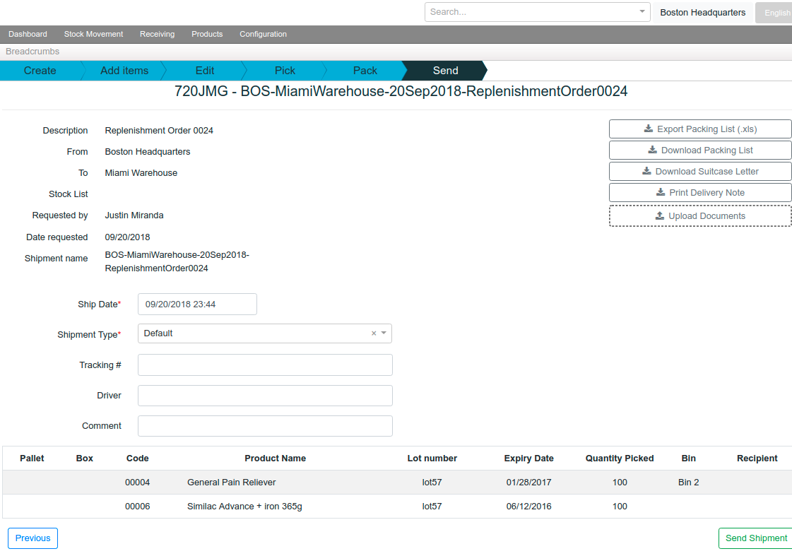

## Inventory Management

The system shall adjust inventory quantity and remove quantity due to expiry and damage. It shall provide the following features

* Track lot/serial number and expiration date through workflows, including automation based on First Expired First Out (FEFO) during picking
* Easily identify affected inventory in the event of a recall
* View and export dashboard reports on expiring stock
* Access information about incoming shipments and pending outgoing shipments for each item by location

### Prototype Screens

#### Track Stock Expiry

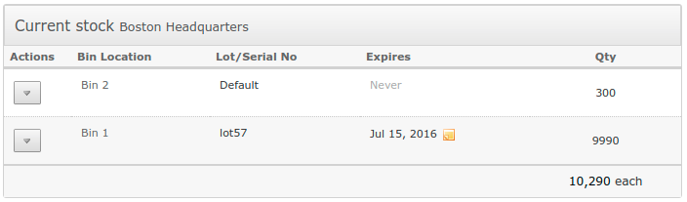

#### Expired Item Report

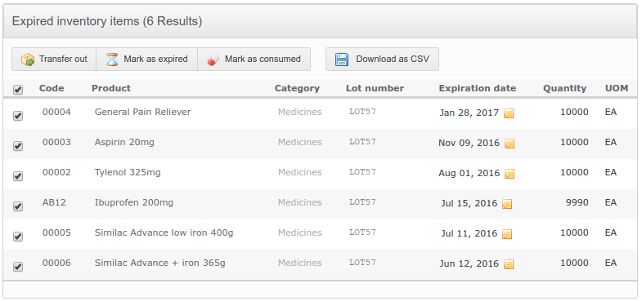

#### Mark Expired Stock

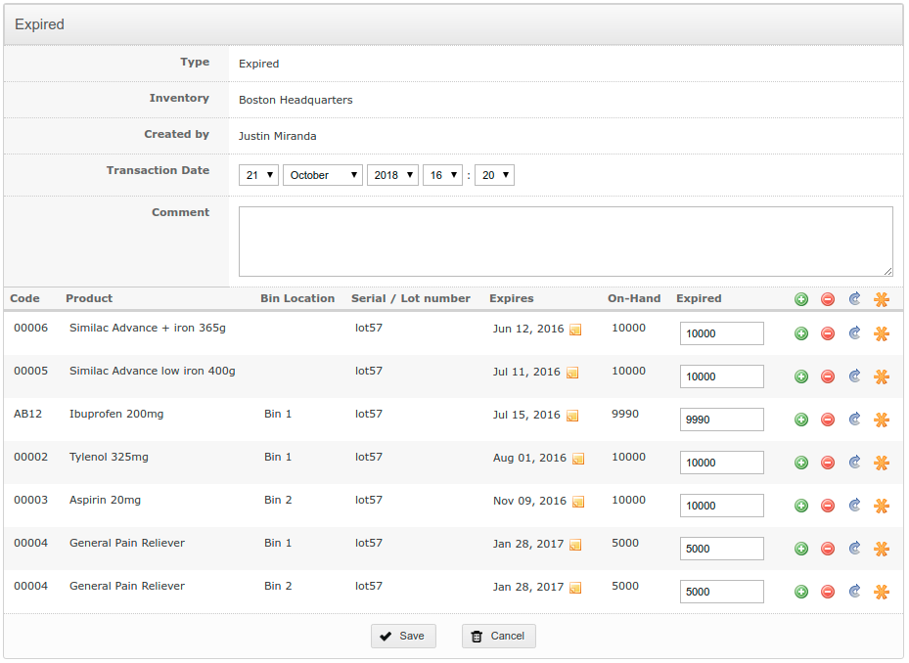

#### Adjust Stock

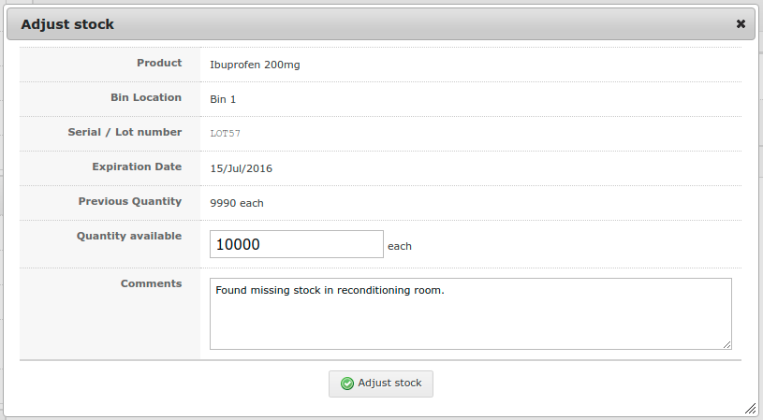

#### Pending Outbound Stock

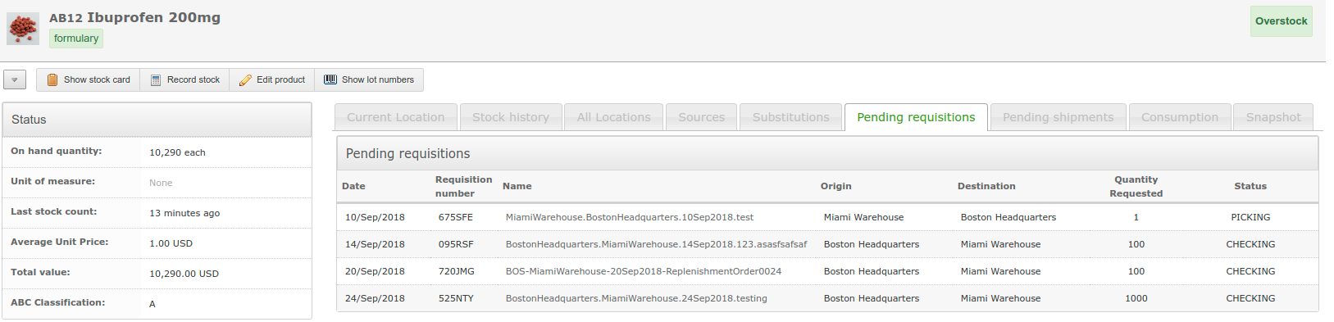

#### Pending Inbound stock

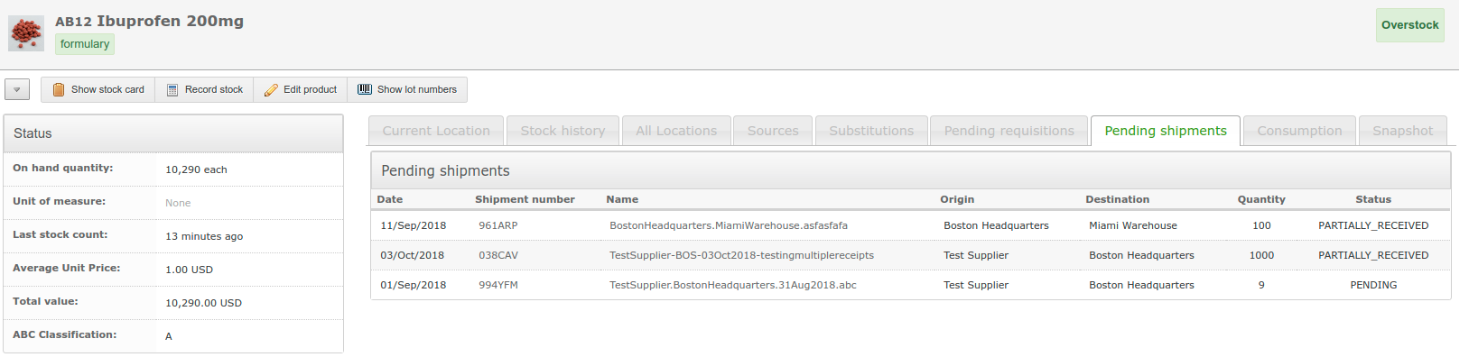

## Dashboard

The application shall have a modern dashboard with useful indicators to help inform stakeholders on important decisions that need to be made and advise users on what they need to work on next.

* Stock value
* Inventory summary
* Bin location summary
* Expiring stock summary
* Fast movers
* Global search
* Product tags
* Recent activities

### Prototype Screens

#### Stock Value

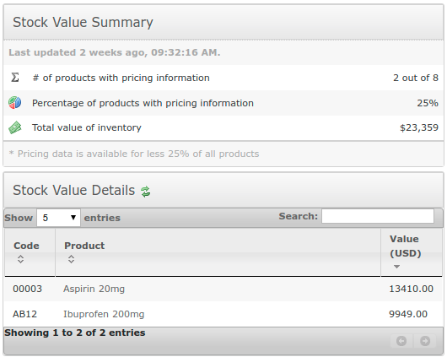

#### Inventory Summary

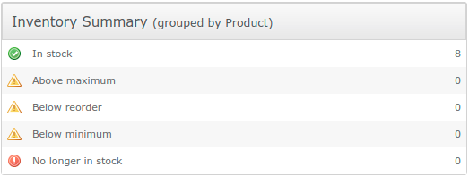

#### Bin Location Summary

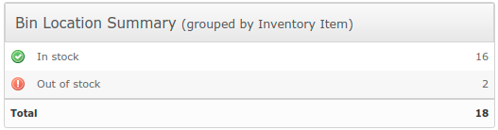

#### Expiration Summary

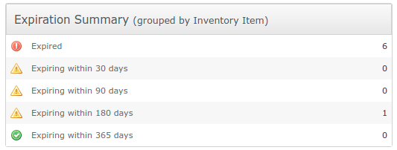

#### Fast Movers

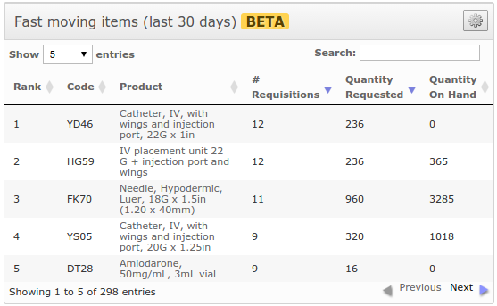

#### Global Search

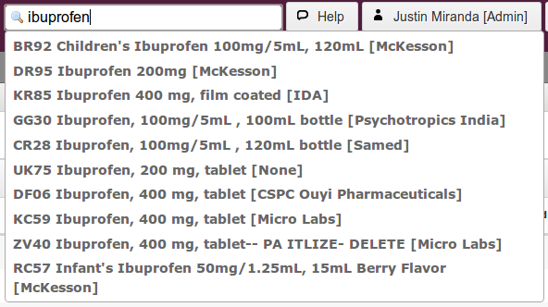

#### Product Tags

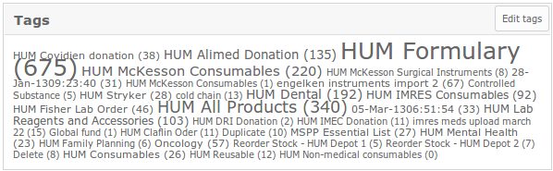

#### Recent Activity

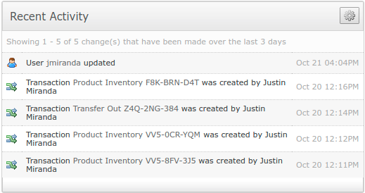

#### Dashboard



## Flexible Location Hierarchy

The system shall allow you to organize and manage stock within multiple facilities, thousands of bin locations, receiving and staging area, supply closets, etc. It shall include the following features

* Location Groups (geographic region)
* Location (facility, storage area, room, closet, locked cabinet, crash cart)
* Internal locations (bin location, receiving area, staging area, cross-docking, bulk storage)

### Prototype Screens

#### Bin Locations

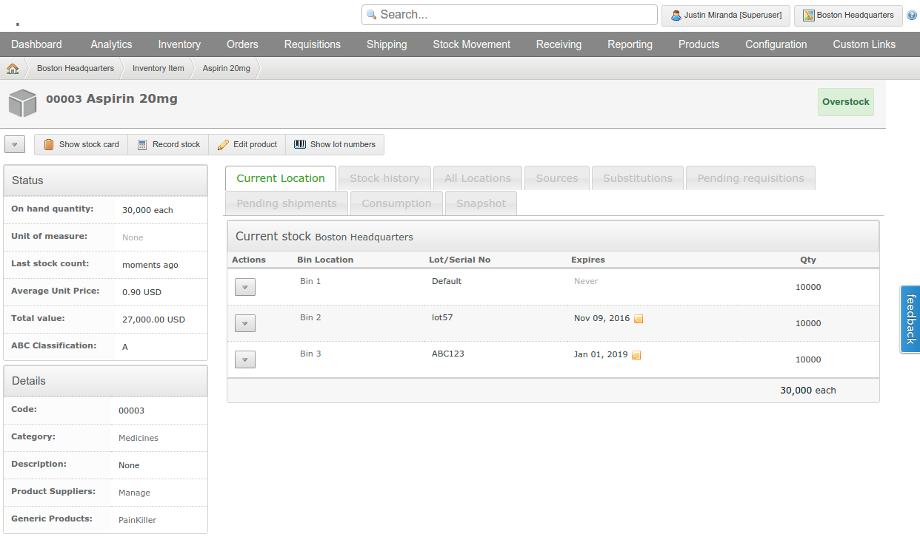

#### Multiple Facilities

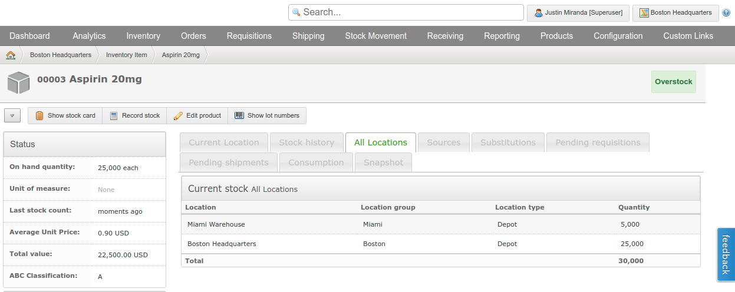

#### Choose Location

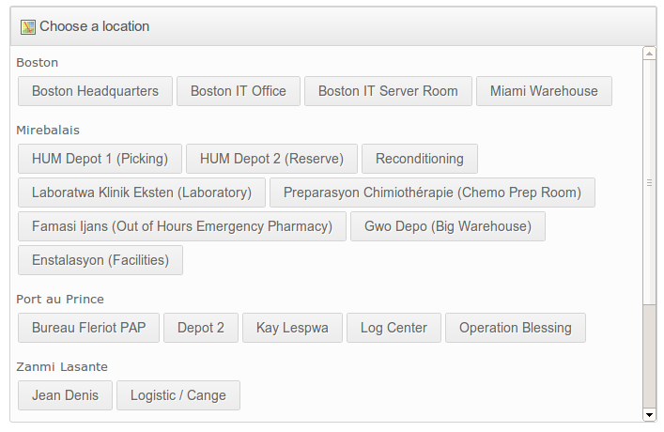

## Reporting

System shall supports utilization and request (demand) tracking; It shall also include reporting features for planning and warehouse management; Customized reports and integration with other software shall be developed

### Prototype Screens

#### Consumption Report

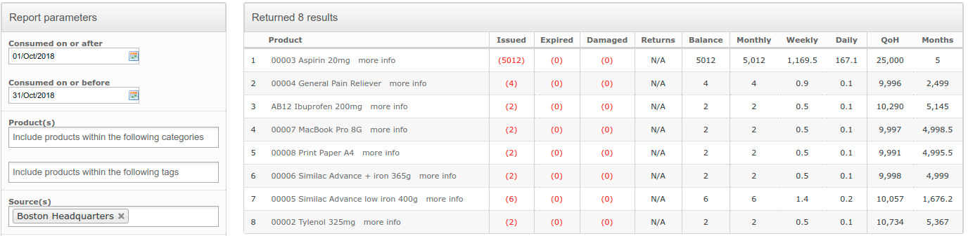

#### Stock out Items Report

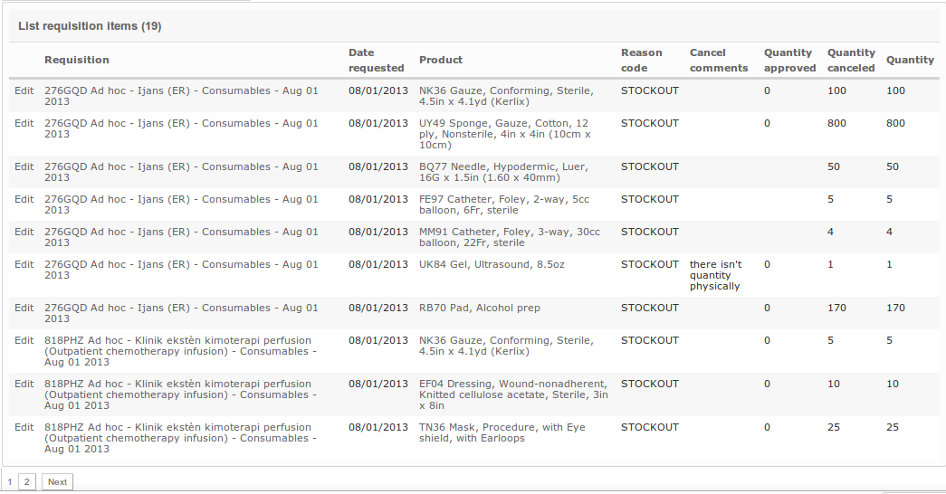

#### Expired Stock Report

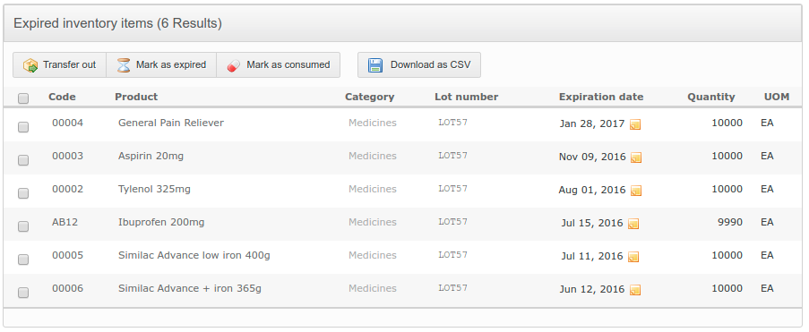

#### Expiring Stock Report

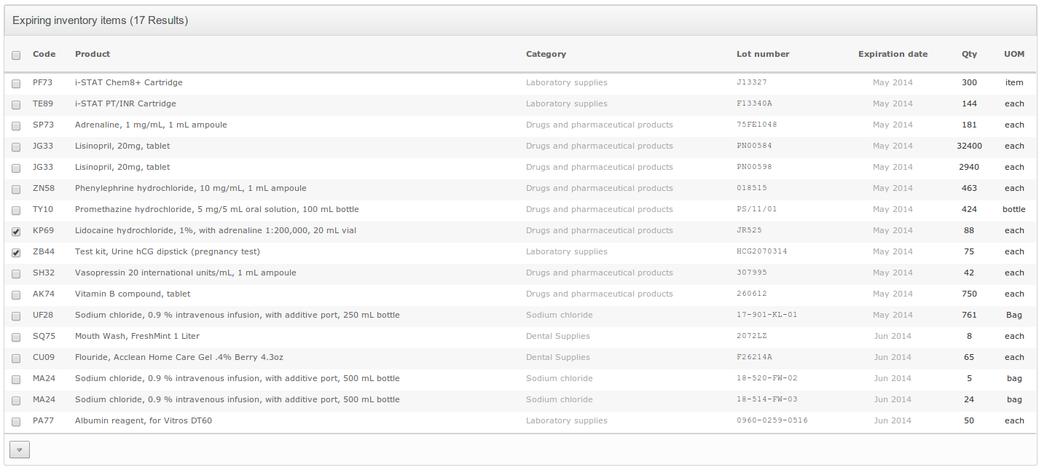

#### Monthly Consumption Data Report

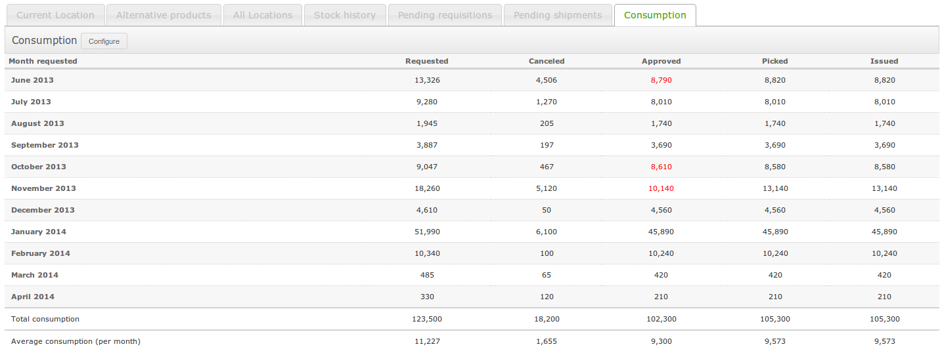

#### Monthly Consumption Data Details Report

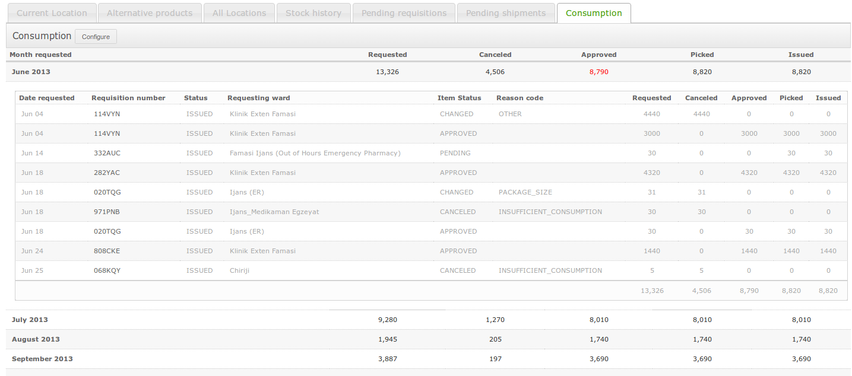

#### Stock Analytics

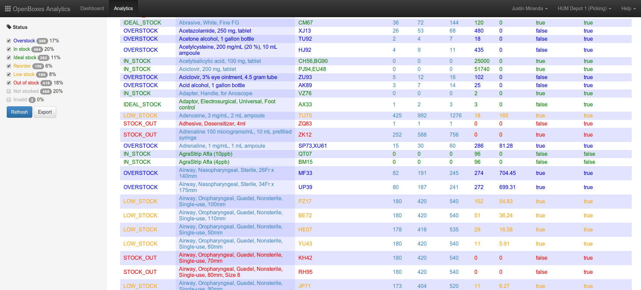

#### Stock Analytics

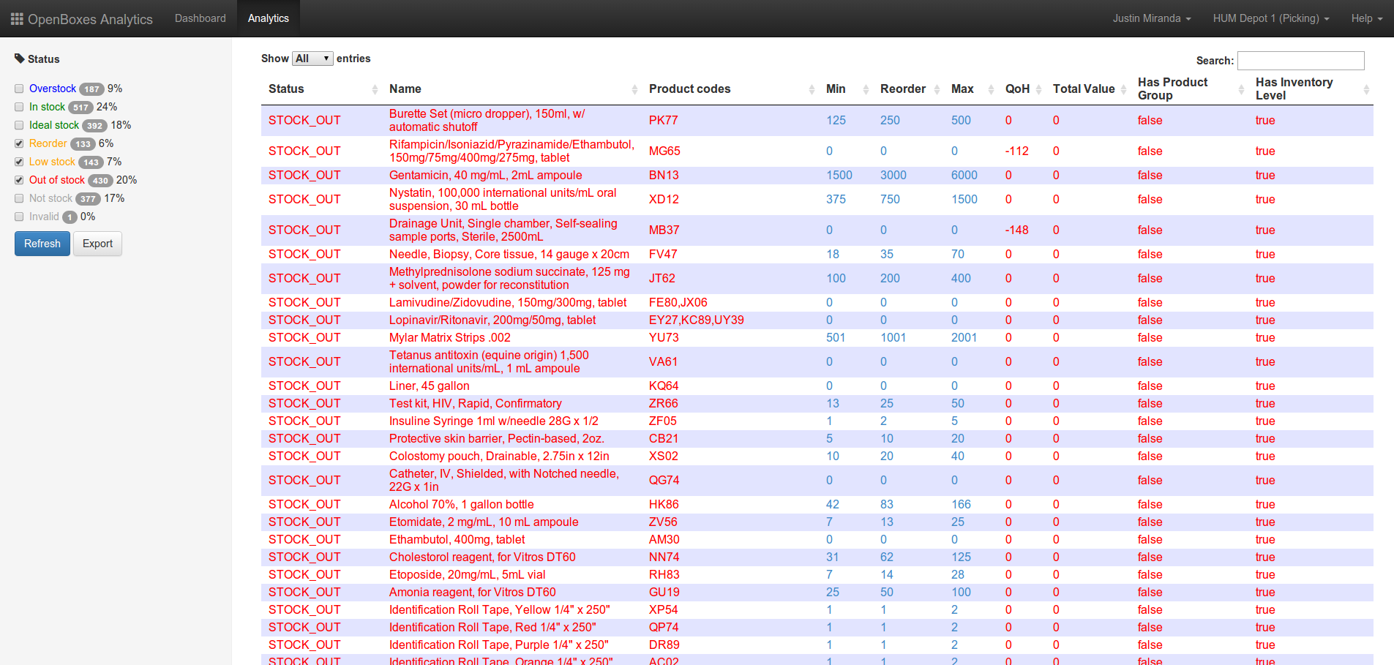

#### Quality on Hand Report

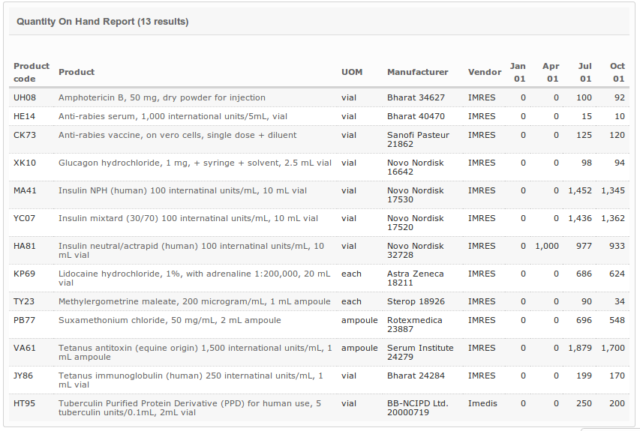

## Security

The system shall assign permission levels by role to the registered users. It shall have the following features

* Auditing of user actions, includes automatic created & updated timestamps for all major transactions
* Multiple roles shall be available (Superuser, Manager, Read-only)
* User access shall be restricted by location
* Ability to authenticate using directory service (i.e. LDAP)

### Prototype Screens

#### Auditing

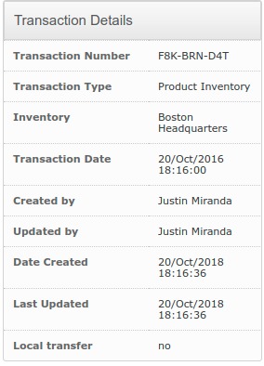

#### User Roles

#### New Account Signup

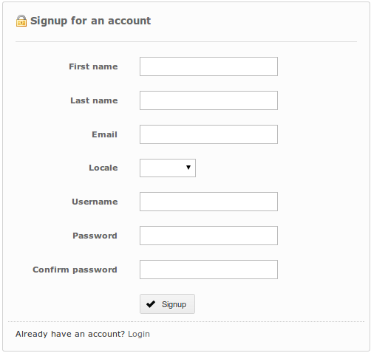

#### Login

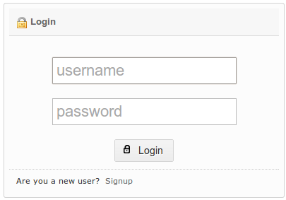

#### Select User Location and Role



## Custom Attributes

The system shall record metadata required for proper handling of particular items.

* Controlled-substance classification
* Temperature requirements (for cold chain)
* Hazardous materials classification
* Import/export license requirements

### Prototype Screens

#### Materials Handling

#### Edit Material Attributes

#### 

## Stock List Management

Organize items and assign to stock lists.

* Ability to organize items by catalog
* Ability to assign items to a stock list by location to standardize and automate stock requests

### Prototype Screens

#### Stock list

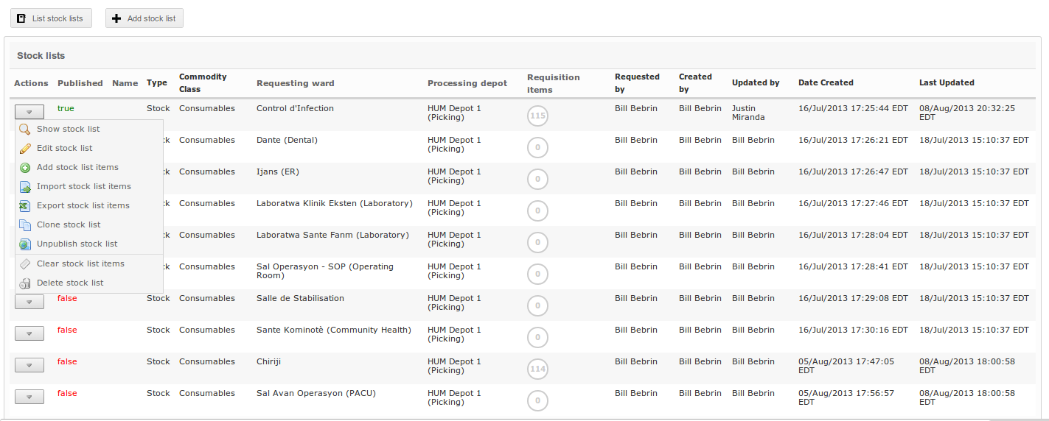

# Benefits of Verbat’s Solution

## Inventory Visibility and Tracking

* System shall allow you to view inventory at a glance, it shall provide a historical record of inventory transactions. This data is invaluable to accurately understand and forecast demand for future planning periods.
* System shall allow you to set inventory max, min, and reorder points — this allows the user to quickly assess if supplies are overstocked, at appropriate stock levels, or in danger of being out of stock if not reordered soon.
* System shall allow you to record the movement of goods from multiple sources and across different levels of the organization:
  + From central warehouses to your facility depot
  + From other facilities to your facility depot
  + From vendor warehouses to your facility depot
  + From one warehouse to other warehouses within your network
  + From your facility depot to wards within your facility
* Record lot numbers for items that have an expiry date to help identify stock that has expired or is about to expire. Lot numbers also provide a means to locate stock when a manufacturer recalls a certain item.
* Record serial numbers for items that require lifecycle management (including assets such as computers, routers, hospital beds).
* Upload and manage documents for each product (e.g. data sheets, product manuals, hazardous material handling requirements).

## Shipping Documents

* System shall provide the user with the ability to produce Certificates of Donation, Packing Lists, and other documents required for shipping.
* Documents shall also be uploaded to allow operational leadership to save all the relevant shipping documents to a particular shipment within the system.

## Grant Compliance

Certain grants require that inventory be tracked in very specific ways. The system shall allow a site to account for the movement of goods bought with grant monies from vendor, to country, to facility — and the consumption of those items at a facility level.

## Integration with Demand & Forecasting software

While the system’s stock usage history can provide a high-level picture of future demand for any particular item, integrating with demand forecasting software will allow those processes to be automated and more accurate.

## Integration with Data Replication software

While the system shall support a hierarchy of locations, it's not always possible for all locations to access a centralized server due to power and Internet limitations at that site. In this case, one can manage multiple server installations (a central server for most locations with good Internet) and a separate server for each location that does not have a reliable connection to the Internet. Using [SymmetricDS](http://symmetricds.org/), one can bi-directionally sync all data changes between each of these servers.

## USER CHARACTERISTICS

The applications authorization mechanism shall currently provide three roles (Admin, Manager, and Browser). This limits the ability for an administrator to create roles based on fine-grained permissions. For example, all Manager users have the ability to perform CRUD actions (create, retrieve, update, delete) on most objects within the system. However, one cannot create a new role (e.g. Shift Manager) that allows a user to create a Product, but not a Purchase Order. A more fine-grained approach shall be implemented if the project were split up into different phases with additional functionality added in a future phase.

## PROPOSED SOLUTION MODEL

Verbat will be following a stand–alone fixed bid solution delivery model wherein the required solution for Phase One would be devised. Verbat’s solution architects have conducted a thorough research on the requirements and have come to the conclusion that our proposed solution, which is detailed further in this document, will meet the requirements put forth by the client.

**Key Strengths of Our Solution**

* Strong and Scalable platform accommodating to future enhancements.
* A framework which acts as a solution accelerator with building blocks that can be re-used in the future for building new components and features.
* Our light weight framework consumes fewer system resources thereby making the application perform faster.

# FUNCTIONAL REQUIREMENTS

This section details the functional requirements specifically mentioned in the RFP.

## Warehouse Order Processing

The system shall contain all the names of the consumable items + released QTY and the requested quantities. (Sub-stores) Dubai and Sharjah.

The warehouse department receives the electronic order then process it as following:

* Scan the material’s barcode using the barcode scanner (the international barcode number), to insert the released materials.
* Minimum inventory and product expiry date will be sent by e-mail notification and through the warehouse system.
* Order system of other departments and receipt of the requests through the automated system.
* Entering materials in the traditional way.
* Release the materials using the factory barcode.
* Print the report of the materials released on the same day of release.
* Storing all materials release transactions on the same day of release.
* Storing all materials release transactions on via the system.
* Comparison of standard stock investment

## Stock Investment standard:

* The number of times the service is interrupted or delayed/ stock shortage/Out Of Stock.
* The number of times in which the warehouse department postponed the committed dates of delivering the products.
* The average waiting period to deliver the items to the requesters.
* The number of times the warehouse department did an emergency or direct purchase.
* The size of the losses caused by the prices increases of some items needed by the departments, and did not maintain sufficient stock in the Department Stores.
* The size of the losses caused by the prices decreases of some items needed by the departments, and retain large quantities exceeding their actual needs.
* The size of the losses resulting from the sleeping/ idle or obsolete stock, which is usually the result of poor planning. Therefore, the amounts must be allocated to stock investment and to provide the needs of the materials with the specifications and quantities required in a timely manner.
* The quantity of demand (the economic quantity of the purchase)

## Equations

* Requested quantity (economic quantity to buy)
* Waiting period = Daily consumption rate of item X Waiting period (purchase).
* Minimum stock = daily consumption rate of item X The number of days desired to be kept in stock.
* Re-ordering point = minimum stock + (average daily consumption of the item x waiting period)
* The maximum limit of the stock of a given item = the minimum stock + quantity of demand.
* Any other important equations.
* The expected available balance = the balance of the material in the warehouse + the quantity insured - the amount expected to be released during the year
* Required quantity = total requirements - expected balance in stock
* Proposed amounts for item insurance = Quantity requested X Unit price

## Stock Movement

* Monitoring and following up storage levels for each item (storage levels are minimum, maximum and re-order levels)
* Determine the economic quantity of the purchase, if the stock balance reaches the re-ordering limit
* Submit a request for the procurement of the organizational unit for the procurement of materials which reaches the re-ordering limit.
* Knowing inventory balances of items and their total value with the preparation of the necessary data and reports on the stock and provide it to the relevant departments.
* Control stock movement of items by identifying items that are fast moving, slow moving or sleeping stock.
* Supervising inventory work, matching inventory balances and actual inventory balances.
* Identify inventory problems and their causes in terms of stagnant, lost or damaged items.
* Limit similar items in stores.
* Inventory and follow-up of items outside the scope of use.
* Coordination on the disposal of materials and items outside the scope of use either by exchanging, circulating, selling, donating, repairing or destroying them,

## Determine inventory levels:

* Stock is a Non-productive capital
* Extra stock needs additional costs
* Possibility of non-waiting in the process of supplying stores
* Possibility of exposure to the risk of out of stock and interruption of work

## Minimum Inventory levels

* The time required for the supply of each local or foreign item of and the procedures for its purchase and supply
* Depreciation rates according to the operating programs and the maintenance and repair required

## Re-ordering limit

* Calculate the minimum storage capacity in addition to meet the operational needs within a period of time starting from the time of preparing the order until the date of receipt of materials and items in the warehouses.
* Availability of materials and items in the market.
* Balance of the item.
* Material requests that have been canceled or not yet been completed.
* Materials or items contracted and not supplied.

## The highest rate:

* The susceptibility of materials and items to storage and their exposure to damage
* Availability of materials and items in the market
* The extent of change in specifications from time to time
* Price fluctuations
* Possibility of storage
* Material requests that have been canceled or not yet been completed.
* Materials or items contracted and not supplied

## Classification of materials in stores:

* New materials
* Used materials
* Damaged materials

## Where the movement (operational status)

* Active items
* Inactive items

## The rate of movement speed:

* Slow moving materials
* Natural movement material
* Fast moving materials
* Sleeping stock

## Period of validity of consumables:

The validity period is determined

### Defining the inventory strategy:

* Identify active materials in stores
* Identification of inactive substances for disposal
* Follow-up and maintain the strategic materials.

## Stock movement reports:

Several daily, weekly, monthly, and yearly reports can be generated on stock movement and stock in quantities, values ​​and status.

* Date
* Name of store
* Name of the item / category
* The item number or barcode
* Storage location - (shelf number)
* The opening balance of the item (number + value)
* Quantity of materials received during the period and value in AED
* Amount of materials released during the period and value in AED
* Quantity of materials transferred internally (between different stores belonging to the same federal authority) during the period and value.
* Quantity of materials that were exchanged through inter-exchange at the level of various federal agencies during the period and their value in AED.
* Current balance of material (number + value)
* Inventory turnover rate
* Inventory turnover rate = Sales cost / ​​Average inventory.

## Calculate the average duration of material in stock:

* Days = number of days of period (365 in case of full year)
* Days = inventory turnover

## Extra items (Unused items):

* New materials not used
* Used materials
* Old materials
* Damaged materials
* Slow moving materials
* Materials near expiry within six (6) months.
* Expired Articles

## Evaluation of safety and security programs:

* ***Frequency of infection average:*** Frequency of infection = Number of infections / Actual working hours of workers X 1000 hours
* ***The severity of the infection rate:*** Frequency of infection = number of days of absence resulting from injury /actual hours of work injury X 1000 hours

## Types of stores:

* Stationery Store
* Furniture Store - Assets
* Supply Store
* diplomatic mission store
* IT Management Store
* Consular Services Department Store
* Department of Finance Store
* Government Communication Store
* Project and Facilities Management Store
* Store damaged items
* Protocol Department Store - State flags (Protocol Management Store - State Information)

## Note:

Store of Department of Consular Services, addition of three categories of items:

* Stickers of ratifications within the country (adding a digit for the ratification stickers box number)
* Posters of ratifications outside the country (adding a digit for the ratification stickers box number)
* Visa stickers (adding a digit for the Visa stickers box number)

# APPLICATION ARCHITECHURE

The proposed application is a web-based system that can be hosted in the cloud or on premise; there is no need for a license, so there is no limit to the number of simultaneous users

* System requires consistent internet connectivity for cloud-based system
* System requires human resources and hardware to support on premise system with offline capability
* There are no limits to the number of users who can use the system at one time
* There are no limits to the number stock locations you can manage
* Can be accessed from mobile devices
* Can be integrated with third-party software systems through REST API
* Can be integrated with barcode scanners and RFID receivers

## Deployment Options

## Technology Architecture

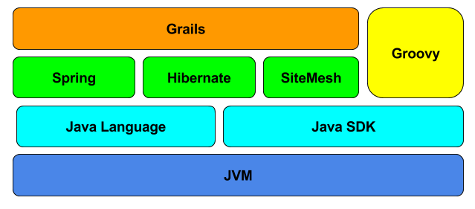

## Server Architecture

## NON-FUNCTIONAL REQUIREMENTS (OTHERS)

|  |  |
| --- | --- |
| **Requirements** | **Details** |
| User Experience and  UI Design | * The application will be developed only in English * The layout and graphical components will be created considering the usability factors |
| Performance | * Application will allow users to have smooth and quick access to the information or services they require. |
| Security | * Web security standards will be followed. |

## TECHNICAL CONFIGURATIONS

### DEVELOPMENT ENVIRONMENT

* Java, Grails, Spring, Hibernate, Tomcat
* MySQL or Oracle
* HTML / CSS 3
* JSP, Struts
* Eclipse or IntelliJ, JDK

### RECOMMENDED WED HOSTING PACKAGE - DEDICATED

* Operating System: Windows Server
* CPU: 2 cores
* Domains: Unlimited
* Disk Space: 200 GB
* Monthly Bandwidth: 50 GB
* Apache Tomcat
* JavaVM, SDK
* Hosting will be on cloud according to the band-width.

### BROWSER

The application developed shall be compatible with the browsers listed below:

* Internet Explorer 11
* Mozilla Firefox 50 or above
* Chrome 50 or above

### HARDWARE DEVICES

#### Mobile device with the following specs (Access from mobile browser)

* The device should support LTE / Wi-Fi 802.11 a/b/g/n/ac
* The device should have 3 GB RAM and above memory

#### Web Server

We recommend the specification mentioned below for the best output:

* Microsoft Windows Server 2016 with IIS 7.5 +
* Processor: 4.20 GHz Intel Core i7-7700 or equivalent
* Memory: 16GB
* Disk Space: 1 TB of free disk space

### TECHNICAL STANDARDS

* Testing Devices

Google Pixel     Android 7

Motorola Moto G Turbo Edition -   Android 6

* OS Version

Android: Android KitKat and above

IOS: IOS 9+

### TECHNICAL GUIDELINES

These guidelines provide instructions and conditions that will be adhered to during the development of the mobile application.

* API will be used, as the case may be, in realizing the features and functionalities mentioned.
* The client will finalize the functional requirements and UI/UX before the commencement of the project.
* Verbat will be testing the app in the mentioned devices only. Testing on devices other than the ones mentioned under the “Technical Standards “will have to be specified and provided by the client at the beginning of the development phase.
* The client will have to provide the details of the testing devices they are using before the start of development phase.
* Client should provide the relevant Developer's Account credentials before the development phase. In case Verbat needs to create the developer id, additional charges will be incurred by the client.
* The duration mentioned in the project timeline is for the development and testing; any delay or time taken by the review team to respond will not be Verbat’s responsibility.
* Any clarification required from client needs to be addressed within 02 business days.
* The apps will be developed / created within the guidelines of respective play store.
* Verbat will strictly follow the guidelines provided by the respective stores.
* Verbat will inform the client if any of the client requirements / request deviate from it.
* Customization of the features of the app will be susceptible to the limitation imposed by the respective platform/ store.
* Once development commences, the test device/screen sizes will not be susceptible to change. Any change requested by the client will have to go through change management.
* OS version support will be limited to the ones mentioned in the technical specifications. Further support will have to go through change management.

## PROJECT DELIVERY

### Agile Methodology

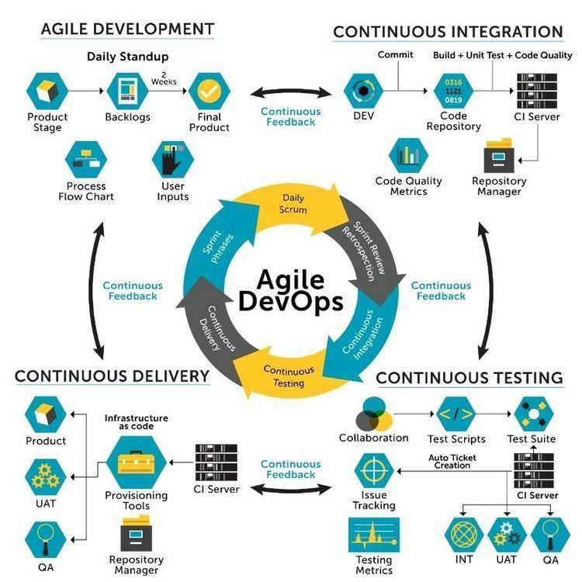

Verbat’s philosophy has been to deliver products that allowed clients to be intimately involved with the development activity. As early as 2005 Verbat had adopted the agile development practices into its pipeline for software development. This allowed clients to closely observe the product being developed. It created a tight feedback loop that allowed us, along with our clients to better understand the requirements and build a right sized and proportional product.

With the advent of next generation applications and tools that support a wide range of activities related to development, deployment and integration; the feedback loops became tighter and coupled, while at the same time it allowed us to create applications that were decoupled. Thus giving us the capability to have greater flexibility in development and deployment.

While development broke down the barrier between developers and management, Devops broke the barrier between software developers and operations teams. Our development and operations teams work under a single silo. While our Scrum teams are cross functional, in our quest to adopt better integration with operations, we have realized that Devops is not just a set of tools and processes, but a mindset and culture. We have fostered a culture collaboration and communication. Our scrum teams and Devops teams share a symbiotic relationship and they work united towards a common goal.

As a company, we have adopted the following tenets in our Devops philosophy

**Speed:** i.e. Move at a high velocity so as to innovate faster for customers and adapt to changing markets better, and grow more efficient at driving business results.

**Rapid Delivery:** Increase the frequency and pace of releases so we can innovate and improve products faster and thus respond to customers’ needs and build competitive advantage.

**Reliability:** Ensure the quality of application updates and infrastructure changes so we can reliably deliver at a more rapid pace while maintaining a positive experience for end users.

**Scale:** Operate and manage infrastructure and development processes at scale.

**Improved Collaboration:** Build more effective teams under a DevOps cultural model, which emphasizes values such as ownership and accountability. Developers and operations teams collaborate closely, share many responsibilities, and combine their workflows.

**Security:** Move quickly while retaining control and preserving compliance. We adopt a DevOps model without sacrificing security by using automated compliance policies, fine-grained controls, and configuration management techniques.

Please see below an illustration of our technology stack. The tools of the trade that allow us to practice an Agile and Devops centric framework

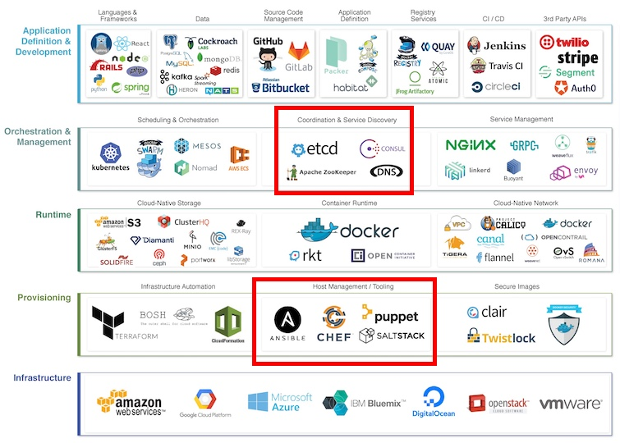

### PROJECT MANAGEMENT

The Verbat development center strictly follows industry standards on quality. Our project management process is governed by the Verbat Quality Management system and is verified through internal audit programs.

Verbat will dedicate a project leader for the proposed implementation. Furthermore, Verbat proposes the client to identify one project manager (*CSPM – Client-Side Project Manager)* who will be driving all activities undertaken by the client, and will be the single point of contact for Verbat.

### ROLES & RESPONSIBILITIES

Verbat will assign its own dedicated Project Lead (*VPL – Verbat Project Lead*) for the client. The VPL will be responsible for planning and management of all activities related to the project. Furthermore, the VPL will work closely with CSPM, on all periodic status updates and will ensure high level visibility and comfort on the progress of the project.

### DELIVERY ACTIVITY SUMMARY

|  |  |
| --- | --- |
| Activities | Description |
| Proof of Concept | Working Model of the project with two languages. |
| Detailed Requirement Analysis | Verbat team to conduct detailed study of requirement for the phase. If clarification is required, the team will reach out to Client for more information and/or time for discussions. |
| DB Design | DB design for central and test DB. |
| Software Requirement Specification document (SRS) | Once the requirement analysis is completed, Verbat team will submit the SRS document for approval |
| UI/UX Design, Prototyping | Based on the SRS, Verbat UX/UI team will work on the UI/UX of the screens and submit prototype for approval |
| Functional Specification Document (FS) | Once the UI/UX is approved, Verbat shall submit an FS document for approval. |
| Development | Actual system development starts based on the FS. This involves detailed design and software development of Web Application. |
| Testing | Test Planning, test plan creations, internal, integration testing and user acceptance testing. |
| Deployment | Deploying the latest build in the Verbat Test Server. |

### PROJECT IMPLEMENTATION PLAN

Verbat will be providing the solution in a stand-alone fixed bid approach which ensures minimum viable solution for quick wins with core focus on the long-term business objective and outcome. Once the implementation is over, Verbat will initiate the application maintenance process (*once the maintenance contract is signed*) which continues to extend after the implementation.

### DELIVERABLES

* Proof of Concept
* Project Plan
* Software Requirement Specification Document (SRS)
* Prototype Design
* Functional Specification Document (FS)
* Fully Developed & Tested Application
* Source Code

### ESTIMATED DELIVERY TIME

The timeline estimated for delivering the application will be as below:

* Working days to complete the proof of concept on completion of resource mobilization.
* Working days to complete the SRS & prototype of Language Translation Application.
* Working days to complete the development.

| **Activity** |
| --- |
| Contract Signoff (T0) |
| Proof of Concept-Allocate Resource |
| Proof of Concept-Complete |
| Proof of Concept- Approval (T1) |
| Detailed Requirement Gathering |
| Software Requirement Specification Document (SRS) |
| SRS Approval (T2) |
| System UI/UX Prototype-Complete |
| System UI/UX Prototype-Approval (T3) |
| Functional Specification (FS) |
| FS Approval (T4) |
| Development Phase-Complete |
| Perform QC (Unit Testing and Integration Testing) |
| System ready for UAT |
| UAT Acceptance on Verbat production server (T5) |

*Note:*

* *The above-mentioned timeline is in Working Days.*
* *Upon project confirmation, Verbat requires a lead time of minimum () working days for resource mobilization for proof of concept.*
* *Resource mobilization will be initiated post the confirmation of the project along with LPO, signed*

*proposal and advance payment.*

* *The initiation of the UI/UX/Prototype development is dependent on the confirmation of SRS.*
* *The above-mentioned timeline for development is post-confirmation of FS.*
* *Documentation submitted after project initiation and system study supersedes any proposal or documentation submitted during initial requirement gathering / discussion / negotiation.*
* *Project plan will be submitted post the confirmation of project with necessary payments.*
* *Any delay in getting the approvals of deliverables from client will cause change in timelines and the revised timelines will be updated in weekly status reports shared with client after the project commencement.*
* *All approvals and queries regarding the client requirement and any queries which may hinder the project advancement at any stage should be answered by the client within () business days from the time of initiation, failing which, the time delay will get added to the actual effort and timeline estimated.*

### DEPLOYMENT DETAILS

* Cloud server for hosting the application will be the responsibility of the client.
* Verbat will deploy the application on client’s cloud server after the client conducts the necessary acceptance testing.

*Note:*

* *Hosting the application at Verbat’s production server (hosting charges) will call in for additional charges. In the event, client wants to procure SSL, the same can be provided by Verbat at additional cost.*
* *Only deployment of the application will be the responsibility of Verbat, any additional installation will be charged separately.*

### RELEASE PLANNING

* Client will be informed about the release date and time through email.
* Client performs the UAT

### RISK CONTINGENCY PLANNING

Verbat has identified various risk factors associated with this assignment and understands the impact of these risk factors on the project schedules. The objective of this section is to highlight for both Verbat and client, the risk factors, to analyze the impact of the risks on project execution, and to propose strategies to control and reduce the impact of the risk factors. These various risks, which could arise during the project, are tabulated below along with mitigation implementation.

| **Type of risk** | **IMPACT** | Risk Mitigation | Risk Handling |
| --- | --- | --- | --- |
| Scope Creep | **H** | Functions and features will be detailed in system requirement document and will go through client approval. Once this document is approved, all changes will go through the change management process for impact assessment. | Proper change management procedure will be implemented |
| Delay in client feedback | **H** | The plan is prepared with sufficient lead-time for reviews and approvals.  The client will advise us on all dates connected to the document review and approval. | The request for feedback will be escalated if not attended to at the right time so that the schedules are not affected. Deemed acceptance criterion is finalized up-front and will be followed |
| Non-availability of necessary software, frameworks, database instances and infrastructure at client’s hosting environment (If hosting support is provided by Verbat) | **M** | Client will be informed in advance on these requirements. | Possible impact to schedule |
| Manpower attrition | **L** | All efforts will be made to ensure that all initiatives are process dependent. To mitigate risk Verbat/Client will train a person to ensure all back-ups are in place. | A new person will be appointed as early as possible, provided the required project-specific training and mentoring is in place - to minimise impact of attrition on the project |

*H-High, M-Medium, L-Low, NA-Not Applicable*

## PROJECT ASSUMPTIONS

The project solution and technology are created from the initial understanding of the requirement shared with Verbat through mails and meetings. The proposed solution is based on the following assumptions:

### OBJECTIVES

* The requirement is to develop a Language Translation Application (web, android, iOS) with the functionalities as defined in ‘Functional Requirements’ section

### DESIGN

* Client to provide Verbat with the brand guidelines.
* Color theme shall be provided by the client.
* Client shall provide licensed images and logos in specified size & format.
* Client shall provide the text and associated images for the proposed application. Text should be provided in digital format preferably in MS Word 2013 or above
* Verbat is free to use custom-made template for design, if required.
* The application designed for mobiles will be in portrait mode

### DEVELOPMENT

1

Client shall procure the following services:

* Mesibo Services
* Google Transcribing Services.
* Google Translation Services.
* Application shall be developed as a hybrid application so that it can be deployed on both IOS and Android.
* Additional charges may be incurred for archiving and encryption services (depending on the requirements).
* Peers making use of translation services are likely to experience a latency which is directly proportional to the bandwidth of their network connection.
* Peers making use of translation services may have to converse through an intercom like interface.
* The application requires a fast internet connection for real time communication.

# OUT OF SCOPE

With the ever-evolving digital market, the requirement should be clear to both the parties involved, hence the importance of mentioning the out of scope details of the project. Following are considered to be out of scope while creating this proposal:

* Purchase of images, fonts
* Any language other than English
* Migration of existing data / Database migration
* Content writing / proof reading / Data Replication / Manual data entry
* Content or image procurement or uploading or editing
* Native iOS App Development / Android App development
* Developer account creation and Maintenance (*IOS and Android Store*)
* Adding new features to the application other than mentioned in the functional specifications. Such requests will be handled via change management. For Change management details, please refer to section titled “Change Management” in the Proposal. (*refer page no: 33*)
* Annual Maintenance Contract (*Bug fixing, debugging, enhancements*) – Please refer to section titled “Maintenance and Support”, unless contracted for. (*refer page no: 34*)
* Hosting Infrastructure and Maintenance (*web and email hosting*), unless contracted for.
* Backup solution and Disaster recovery unless contracted for.
* Physical deployment on-site / installation of the application in devices and physical connection, installation of system.
* Integration with third-party, if any, other than mentioned in the functional specifications
* Hardware Integrations / procurement and purchase
* Procurement of SMS gateway / payment gateway / email gateway
* Integration of SMS gateway / payment gateway
* SSL Purchase and installation, if any
* Plugin/template purchases, if any
* API purchases
* OS other than mentioned in the Hardware Interface
* Relevant / related software libraries
* Mobile offline access or operations

# CHANGE MANAGEMENT

Any addition which comes out of the project scope, upon and after the launch of the website will be considered as change management. Verbat recommends the following change management procedures for the same:

* Changes will be implemented only after raising a change request.
* Change requests will be studied and an impact analysis will be performed on the existing work flow.
* Upon assessment of the impact, effort estimation will be calculated and raised as an additional requirement.
* The change request will be initiated only after receiving a formal approval from the client for the additional changes raised.
* Changes which are out of scope will be charged @ per man day rate.

Activities for change scheduled

Modules checked in

Unit testing done

Change request accepted

Informed of the Action

Implementation of changes

Modules checked out

Activities planned and scheduled

Effected modules identified

New system released with change request

Changes made & documented

System

Need for change recognized

User submits change request

Evaluate for cost, schedule & effort

Change control authority

yes

No

## MAINTENANCE & SUPPORT

* Maintenance contracts by default are supported as per the basic SLA terms.
* AMC with Basic SLA is charged at % of the total project value. Additional Effort/change management request will be added towards Total Value of the Project to determine the AMC value.
* Maintenance support is limited to providing application support for ensuring the consistency of the look-and-feel, bug fixes and user issues i.e. maintenance and support of the existing features of the application.
* Support does not in any way cover providing technical or other support to the end users or hardware support. The maintenance agreement does not include functionality changes or feature additions which are handled as change requests which will be charged per man day rate. AMC does not include server support, maintenance and application deployment.
* AMC charges will cover Off-Site Support and Debugging. Support includes E-mail, telephone and video conference (if required). In the event, the application is hosted with the client or if it is a client server development; necessary remote desktop connectivity should be provided for carrying out maintenance activities.
* All maintenance support will be executed by Verbat off-site team. In the event of any need for on-site work, all expenses incurred for such trips (flights, accommodation, meals transportation) will be payable to Verbat by client.
* Gap in AMC - In case if the client does not opt an AMC for a year and wants to renew it after that period, % of the AMC amount for the year for which AMC is not taken will also be payable if the client wishes to renew the AMC contract.

|  |  |  |  |  |
| --- | --- | --- | --- | --- |
| **SLA Type** | **Max Response Time** | | **Max Resolution Time** | **Target** |
| Basic | 1 working day | 3 working days | | Request / incident / problem tickets |

*Note:*

* *Time zone applicable as per India Time Zones (3:30 GMT to 12:30 GMT, Monday to Friday)*
* *Please note that the AMC support shall start only after all the necessary sign-offs (AMC Document) to this effect have been given.*
* *It is not mandatory that the client should opt for an AMC. The client will still be supported on an ad-hoc basis on an agreed man-day rate.*
* *AMC Payment Terms: 100% to be paid as advance.*

AMC Option: Client can opt for time and material based Annual Maintenance, the details of which will be shared post the completion of project.

# TERMS AND CONDITIONS

## ACCEPTANCE CRITERIA

* UAT (User Acceptance Test) sign off should take place within Days from the first release of the application and the acceptance confirmation needs to be mailed to Verbat failing which Verbat will consider the project as approved by the client.
* Any comments and reasons for rejection need to be documented and the same needs to be sent as an email from the official e-mail id of client to Verbat on or before days from the first release.
* Timeframe for acceptance for any further release will be mutually agreed and finalized between client and Verbat depending on the UAT Comments

## WARRANTY

* Verbat shall provide a bug ﬁx warranty at no additional cost for 30 days from the date of acceptance of the project, for correction of any errors in the developed application that may be attributed to Verbat.
* However, this does not cover modifications by Client, or use of the application on an environment other than the proposed environment, or other circumstances outside Verbat’s reasonable control. In such cases Verbat reserves the right to charge for its services.
* All error corrections will be executed by Verbat offsite team. In the event of any need for on-site work, all expenses incurred for such trips (flights, accommodation, meals, transportation) will be payable to Verbat by Client.

## SOURCE CODE & INTELLECTUAL PROPERTY RIGHTS

* Upon completion of the Project and 100% completion of the payment, the client will have access to the source code except for proprietary codes, developer tools and third-party applications etc.
* The solution offered will be the intellectual property of the client and will be made available to the client on an “unlimited license” basis.
* No person or organization, other than Verbat or any person authorized by Verbat in writing, has permission to modify/change the software solution to be eligible to get continued support from Verbat as per the support terms defined under this document.
* Verbat accepts no liability or damages of any kind arising out of use or non-use of the software delivered. The responsibility of testing of software lies with the client.

## GENERAL TERMS AND CONDITIONS

* Offer Valid for 30 calendar days from the date of submission of the Proposal.
* An average of 20 working days are assumed in a month.
* All the development activities will be carried out from our off-shore development center in India.
* All the documentations will be provided in English.
* Third party components may be used to develop this application.
* The scope of the project is to develop the application as detailed in the scope of the project and mentioned in this proposal. Any changes or additions will have to go through our change management process.
* This proposal is derived and concluded from either the RFQ /RFP/data shared via email / information transferred during an initial requirement analysis meeting / tele-conversation. Verbat reserves the right to change the terms of this proposal if the final terms (including the costing), features & functionalities and timelines are changed during the course of the project. Hence any fees quoted / timeline committed in this proposal may not be considered as final unless agreed upon and signed by both parties.
* Web Application will be best viewed only in the environment mentioned in the section Browser Compatibility.
* Mobile app will be best viewed only in the environment mentioned in the section Hardware Interface.
* All source codes and other project artifacts will adhere to the Verbat document templates and internal coding standards.
* The documents delivered to the client include the ones mentioned under ‘Deliverables’ and these will adhere to Verbat’s internal document standards.
* Acceptance criteria shall be based on the clauses which were mutually discussed between Verbat and client at the Requirement Analysis phase. The same will be documented and approved by both parties through official emails.
* In the event that the Client requires any extension of the proposed acceptance schedule, the associated effort and cost of such extension will be mutually reviewed.
* If the project needs to be put on Hold / Stopped, a minimum notice period of 1 week is required along with the duration of the holding period. Thereafter Verbat will make a final decision based on the request.
* If deployment is done in the client’s server, Verbat will not be held responsible for any performance issues arising due to hardware malfunctions.
* The Client is responsible for all data-backups in case the application is not hosted on the Verbat server.
* All source codes will only be delivered or uploaded on the production server after the due payments are made to Verbat.

## GENERAL ADMINISTRATIVE, TECHNICAL & FUNCTIONAL ASSUMPTIONS

* Detailed system study is required before the start of the project.
* During the requirement gathering phase, authorized personnel from the Client’s side are expected to be available for discussions and finalization of the HLD (High Level Design), before the development commences.
* Type of reports, formats if under the scope of the project, need to be specified by the Client before the project sign off.
* Workflows if under the scope of the project, need to be specified/ confirmed by client before project signoff.
* Verbat assumes that all sign-offs from the Client will be provided within the agreed and specified timeframe.
* Client will provide all the necessary contents, both text and imagery, before starting the project in the format suggested by Verbat (if any).
* The client should provide the relevant information and data, well in advance of the execution of the related activity. Non- availability of this information or data may lead to an interruption of work, which may result in a delay in delivery as well as additional costs to the client.
* The Client should possess a server with the technical specifications recommended by Verbat for the proposed application.
* The Client will be provided with a one-time training (train the trainer) on how to use the application via a video conference (maximum of 4 hours). Additional training requests will be charged at cost to the client.
* Cost of all third-party components to be borne by the client.
* Application will support in three languages which are supported by Google Text to Speech API.

# FINANCIALS

## Curriculum Management Application

|  |  |  |
| --- | --- | --- |
| Sl. | Description | Amount (USD) |
| 01. |  | XXXX USD |

*Note:*

* *The above cost is exclusive of VAT applicable in UAE*
* *The above cost includes the cost of third-party service of non-translated calls.*
* *The above cost does not include third-party API purchases.*
* *The above estimate is based on the initial understanding of the requirement grounded on the details shared by client via meetings and tele-conversations. If Verbat finds during the requirement gathering phase that the actual requirements uncovered are different form the original, this might affect the estimates provided and Verbat shall exercise rights to renege on the contract. Clarifications/Changes in the scope during system study/ analysis may call in for additional effort and timeline.*
* *For feature additions, please refer section titled “Change Management “.*
* *LPO to be raised in the name of “Verbanet Technologies LLC” for project initiation*

## PAYMENT TERMS

* % of the proof of concept as advance.
* % of proof of concept on delivery of POC
* % of Language Translation Application as advance.
* % of Language Translation Application on completion of:
* SRS
* Prototype
* % on completion of development in UAT release of the Web Application on Verbat server/Mobile build.
* % of Language Translation Application to be paid on UAT Signoff.

*Note:*

* *Payment should be made within 7 days from the date of invoice.*

### MODE OF PAYMENT

Wire transfer to our bank account

|  |  |  |
| --- | --- | --- |
| Particulars | **Option 01** | **Option 02** |
| Bank Name | Commercial Bank of Dubai | Emirates NBD |
| Account Name | Verbanet Technologies LLC | Verbanet Technologies LLC |
| Account Number | 1000305555 | 1011492858201 |
| Swift Code | CBDUAEAD | EBILAEAD |
| IBAN Number | AE840230000001000305555 | AE61 0260 0010 1149 2858 201 |
| Bank Address | Al Qusais Branch, P.O Box 2668, Al Qusais | Mamzar Branch, Dubai |

*Note:*

* *Bank charges incurred during wire transfer to be borne by the client.*
* *Any local taxes / VAT applicable to be borne by the client.*
* *Client invoices will include VAT charges in addition to the application cost.*



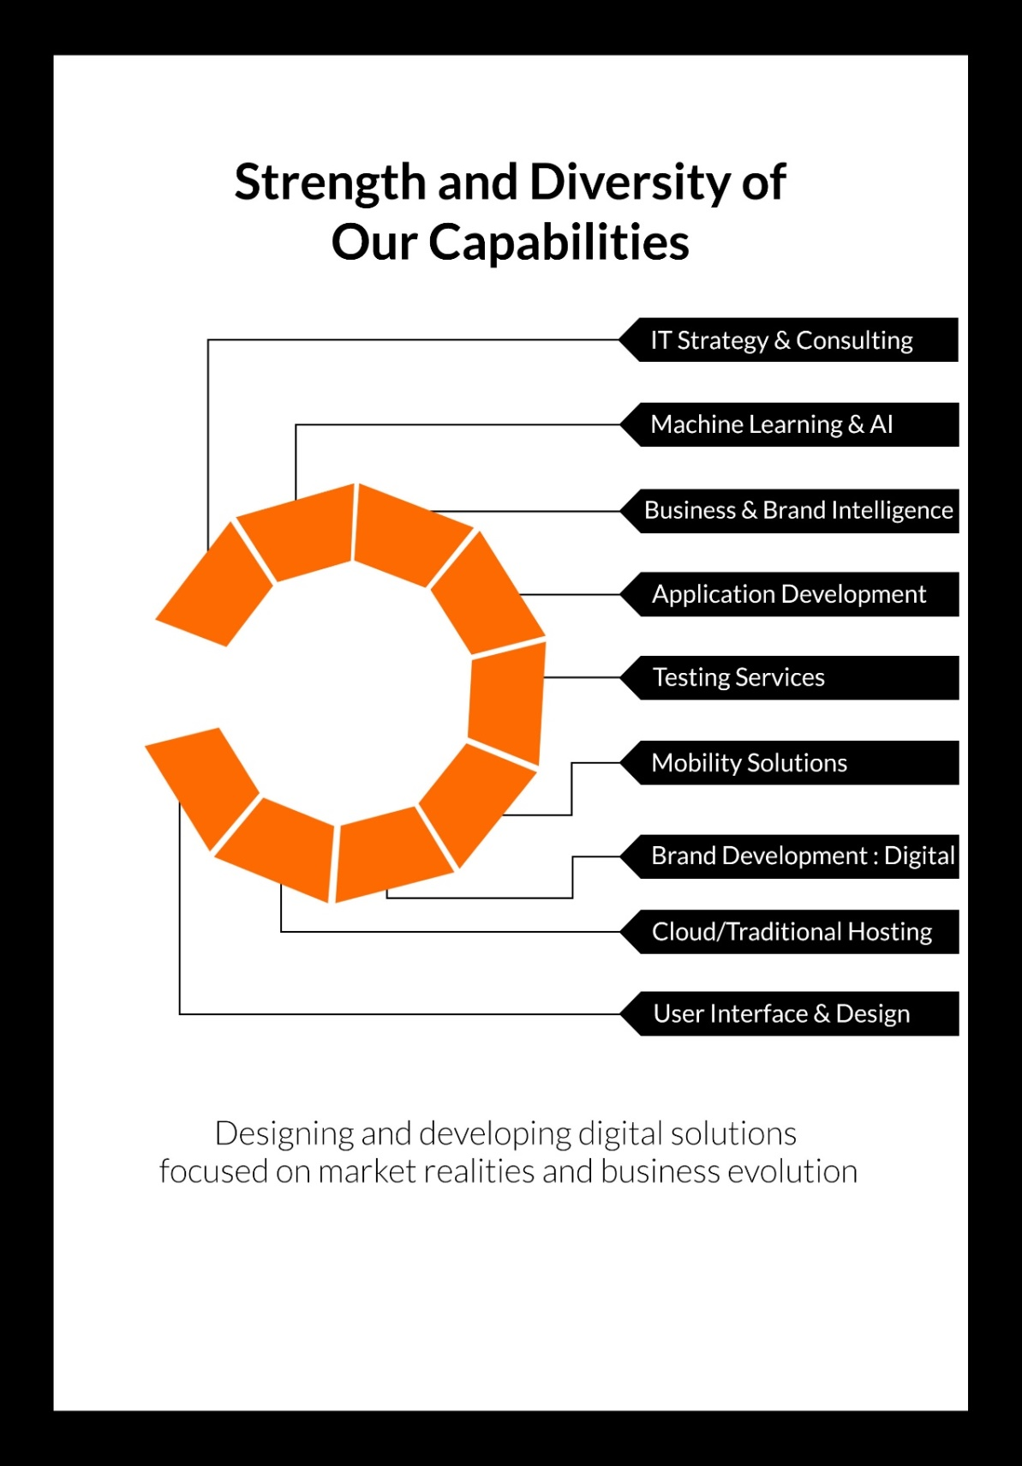

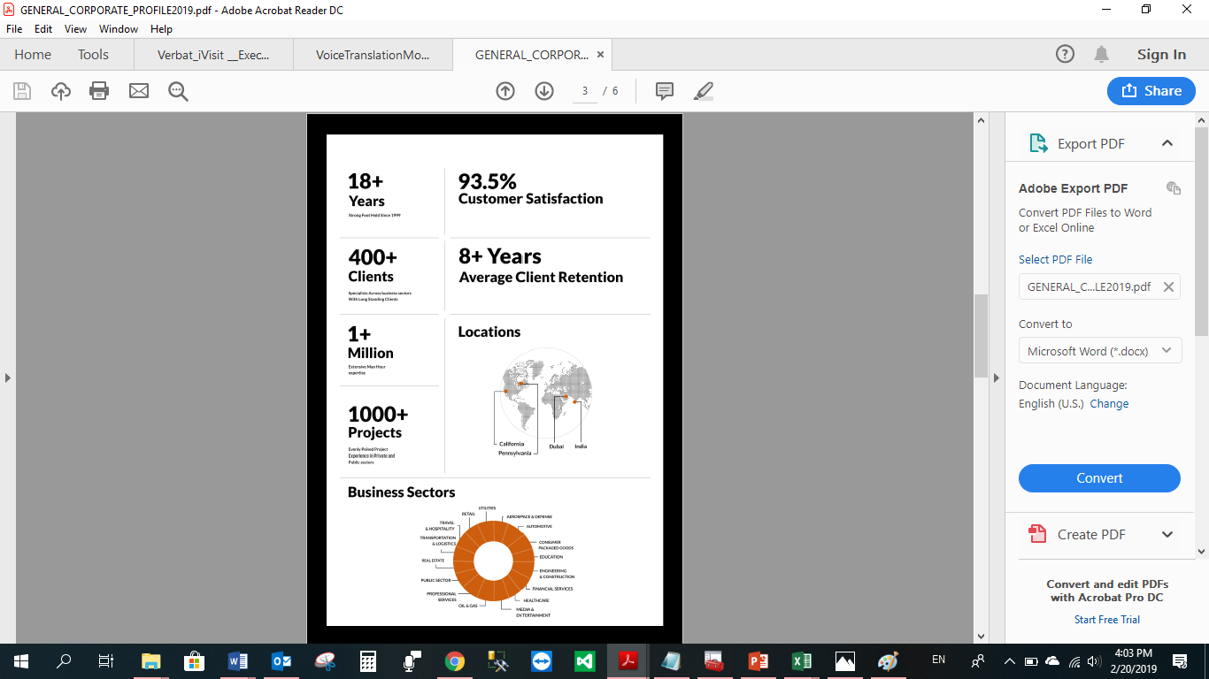

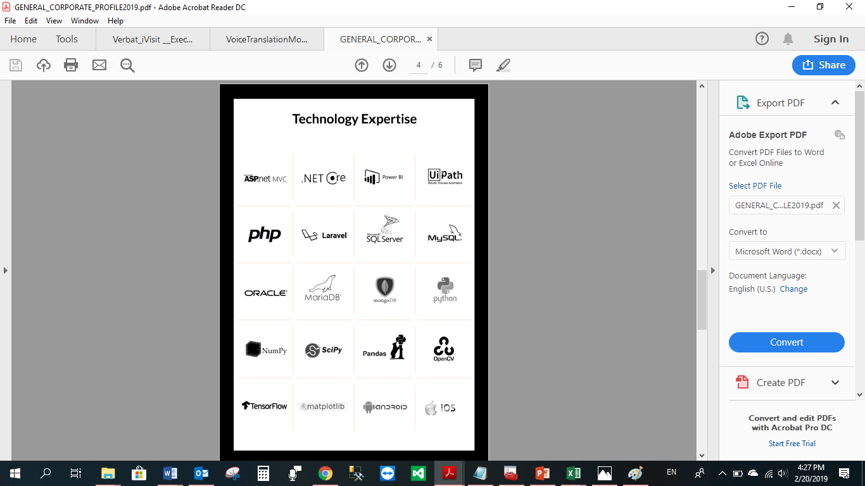

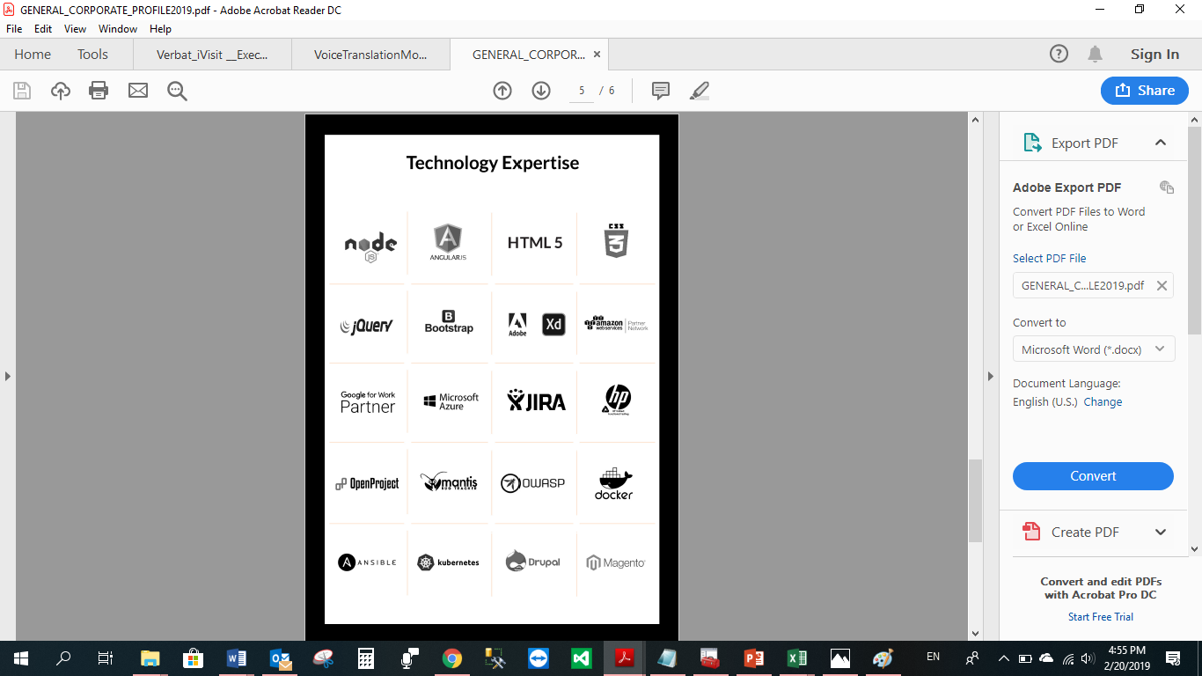

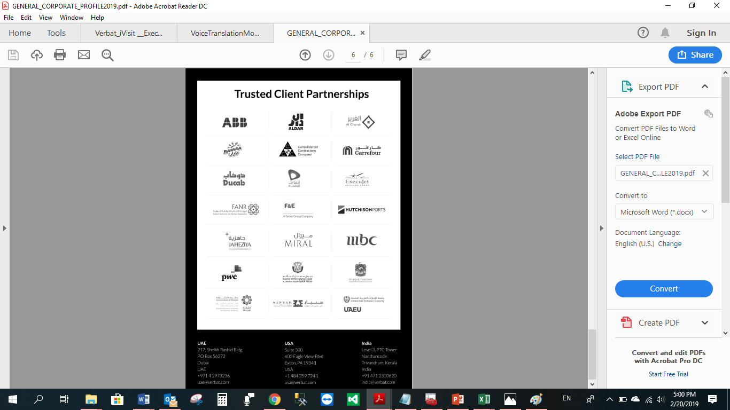

**WITH OUR**

**SINCERE THANKS.**

CONFIDENTIALITY NOTICE:

This Proposal is conﬁdential and contains proprietary information and intellectual property of Verbanet Technologies LLC. Neither this proposal nor any of the information contained herein may be reproduced or disclosed under any circumstances without the express written permission of Verbanet Technologies L.L.C (hereby known under its brand name of Verbat in the United Arab Emirates). 2019. All Rights Reserved.